User Manual

User Training Manual for
Oracle Fusion HCM Cloud

Authors : Charu Vohra
Creation Date : 22-April-2019
Last Updated : 19-Sep-2020
Control Ref :
Version : Ver1.5

Document Control

Change Record
32
Date | Authors | Version | Change Reference
22-05-2019 | Charu Vohra | 1.0 | Initial Document
22-06-2019 | Charu Vohra | 1.1 | Added Changes
21-08-2019 | Charu Vohra | 1.2 | Added delegation process
01-09-2019 | Charu Vohra | 1.3 | Added Absence approval in G. Absence records on page#25
18-Sep-2020 | Sheryar Shami | 1.4 | CR2 changes added (HSBL Upload)
19-Sep-2020 | Abdulrahman | 1.5 | CR2 changes for Consumer Sales User Administration

Related Documents

No. | Document Link | Document

Reviewers

Name | Position

Distribution
Copy No. | Name | Location

Acknowledgements

Name | Meeting/E-Mail

Note to Holders:
If you receive an electronic copy of this document and print it out, please write your name on the equivalent of the cover page, for document control purposes.
If you receive a hard copy of this document, please write your name on the front cover, for document control purposes.

Contents
Document Control 1
Change Record 2
Related Documents 2
Reviewers 2
Distribution 2
Acknowledgements 2
1. Staff Hiring Tasks (Staff from Recruiting Module) 5
2. Personal and Assignment Data Management 12
A. Personal Information 12
B. Assignment Changes 14
C. Manage Document of Records 16
D. Work Schedule management and Assignment 18
E. Termination 19
F. Suspension Process 22
G. Absences Records 24
3. Staff Hire/Re-Hire directly in HCM 26
4. Changes to Assignment Action/ Action Reason 30
5. New Agency/Vendor Creation Process 33
6. Delegation of Access through worklist 34
7. HSDL upload 36
8. Administration of Consumer Sales Department User for Specific User Tasks 43
a. Change or Entry of Location 43
b. Change or Entry of Manager 45
c. Change of Entry of Attendance Source 48

Staff Hiring Tasks (Staff from Recruiting Module)

Once the Staff is hired in Recruiting module (Taleo), their data will be received into HCM. Their record will get created as contingent worker with future start date.
Process Description:
This process will allow HR to complete the hire set up of the candidate(s) record received from Recruiting module.
- Log into HCM using the login credentials using Username and Password. HR who performs hiring.
- Copy and paste the below given URL in the browser address bar. Use Bookmark option to save this URL for regular use.
https://ejdq.fa.em2.oraclecloud.com/fscmUI/faces/FuseWelcome

OR
Etisalat.ae/hr4us
- On the login page, click on Company SingleSign-On

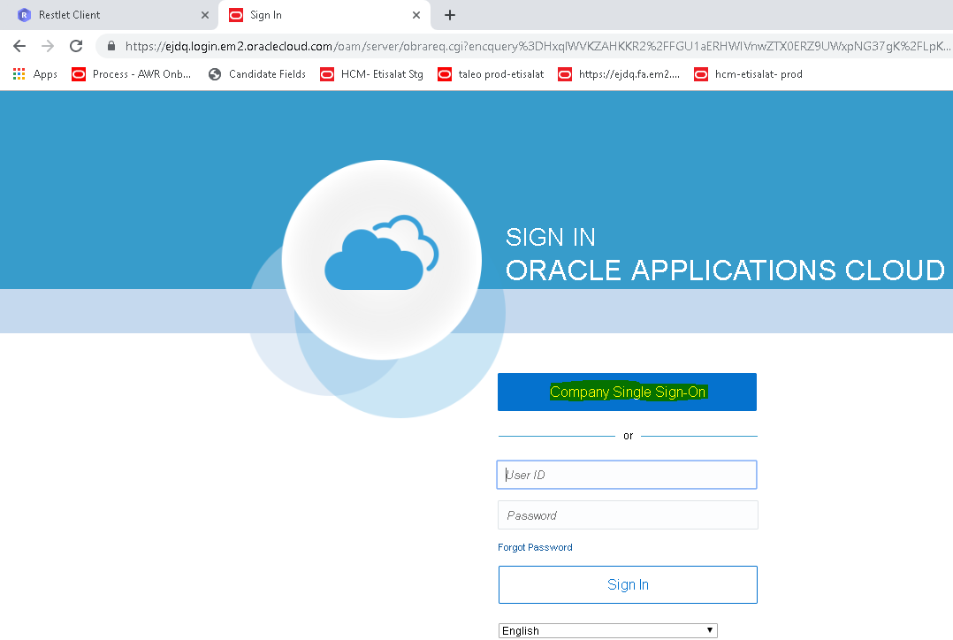

- On the next page, enter the domain id and password provided by the IDM team.
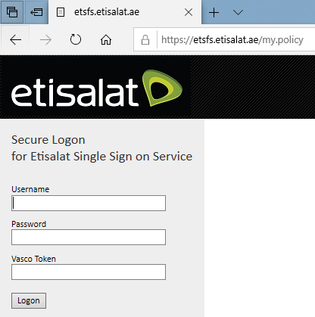
Home Page appears
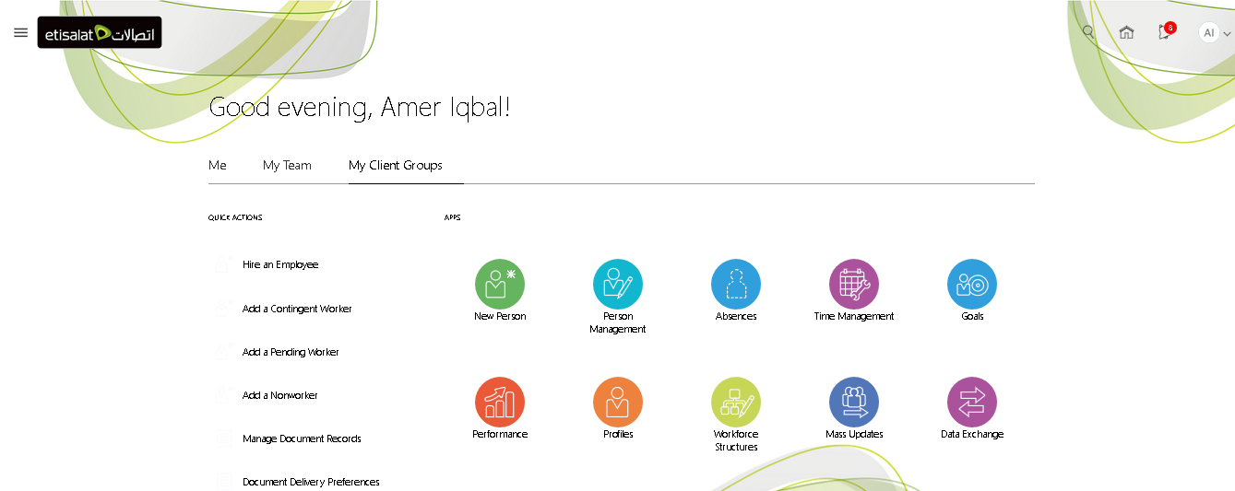

- Click the New Hire report which will show the list of all the new hires with current and future effective date. This report shows all the new hire records received from Recruiting module(Taleo).
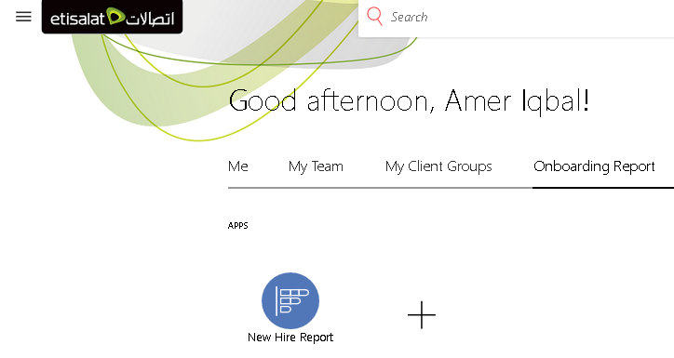
Click New Hire report link to open the report. This report will show all the Staff received from Taleo with current or future start date.
Please note that this report will display staff details to the concerned department(s) as per their secured roles. That is; HR SPOC in Human resource will only be able to see the staffs hired under Department Category “Human Resource”.
This report can also be extracted in excel spreadsheet.
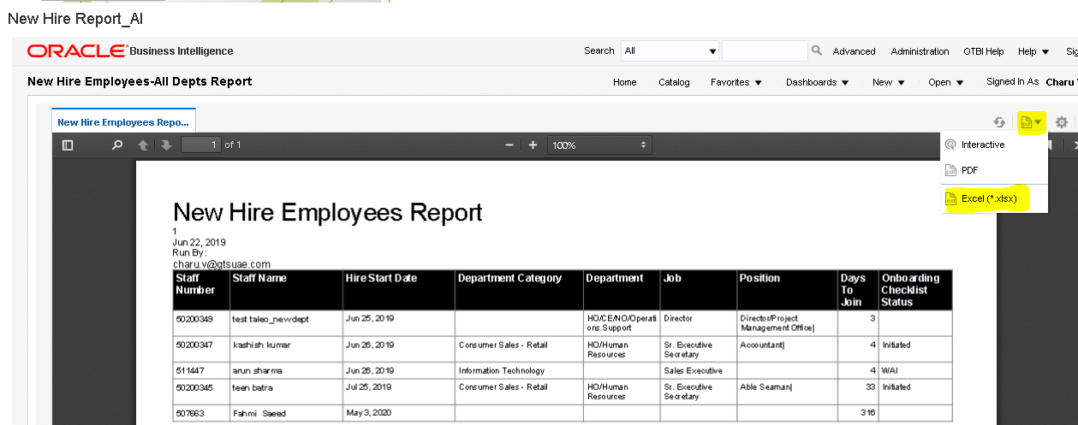
- On the Home page, click the My Client Group > Person Management
- Search for the Staff by his/her name or Person Number. To see the records hired with future date, please ensure to select future date(e.g. 31 July 2019) in the Effective As-of Date field.
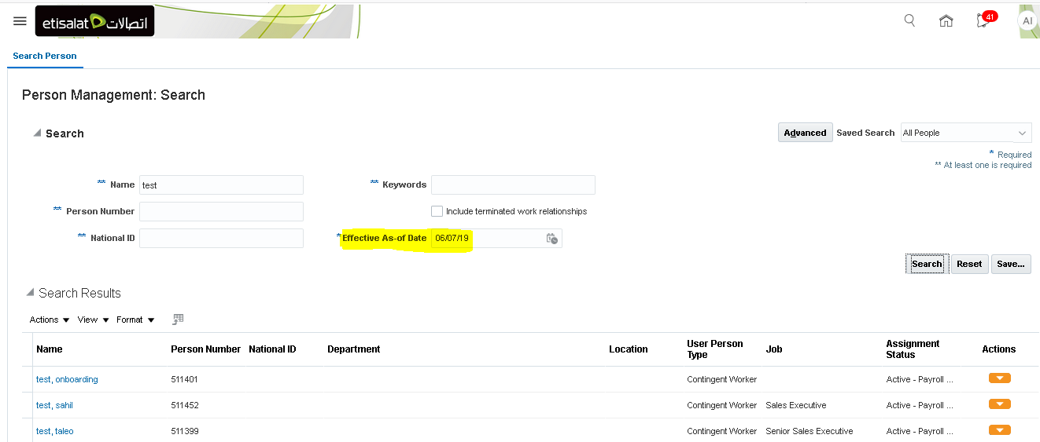
- Click on the Staff’s name hyperlink which will open the Employment page. Validate the Staff employment details to ensure Contract Type, Employment status, department, job, position, Attendence source, Department Category, Agency name(under Peoplegroup field), manager name, Hourly/salaried field are updated correctly. Incase any informaiton is missing, please update the record.
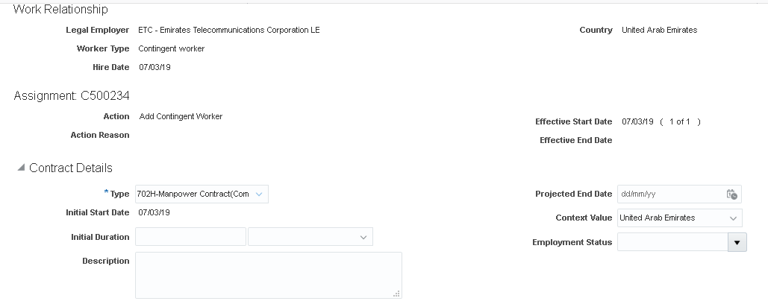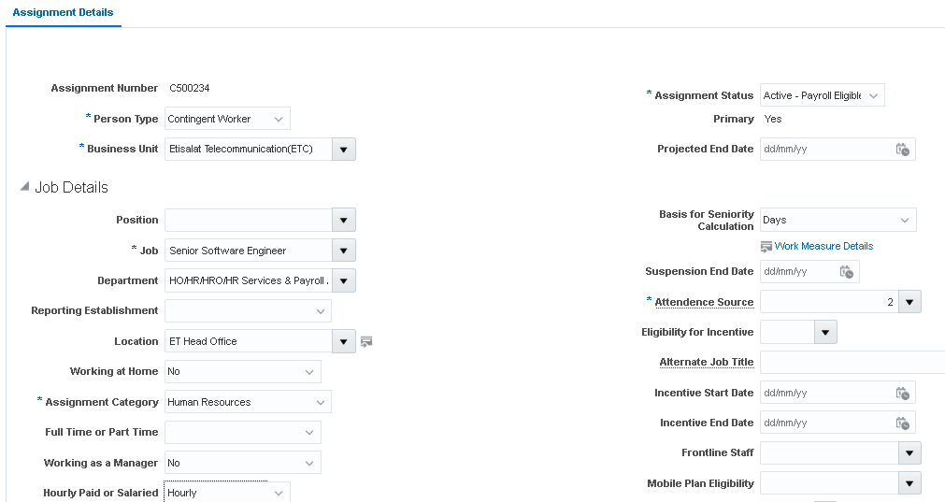
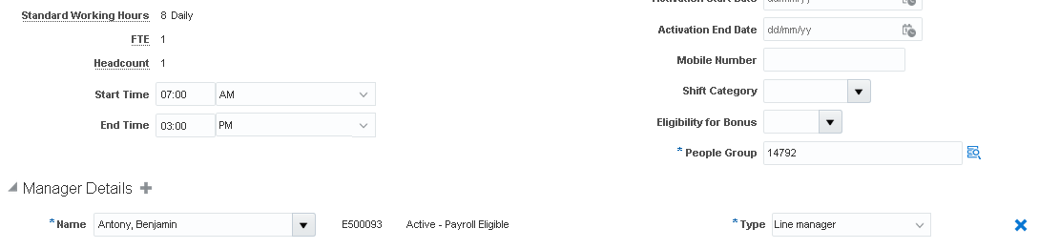
26. In the task bar, select Manage Document Records to review the documents attachments received from Taleo. Like; Resume, Passport, Photo, visa etc. Validate this page to ensure all the required documents have been received from Taleo for the new hire Staff.

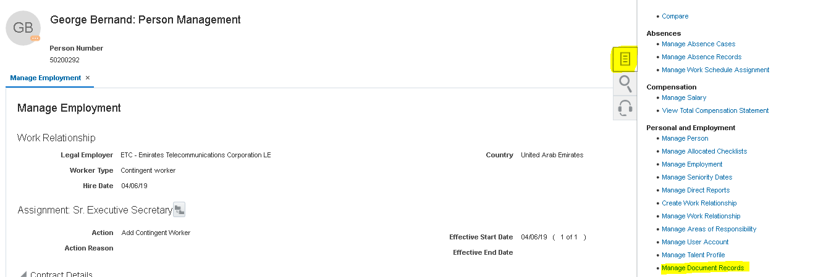
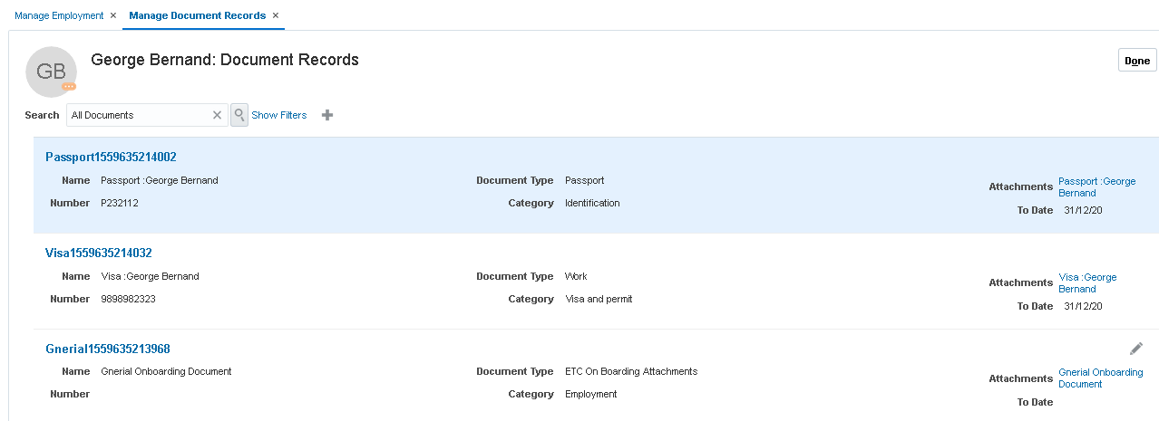
- HR SPOC would need to initiate onboarding checklist for the staff at least 7 days before the joining/start date. Select Manage Allocated Checklist from the TASK bar.
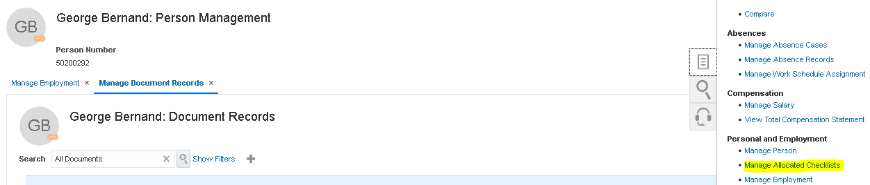
- In the Mange Allocated Checklists page, click on 3rd icon on the page.
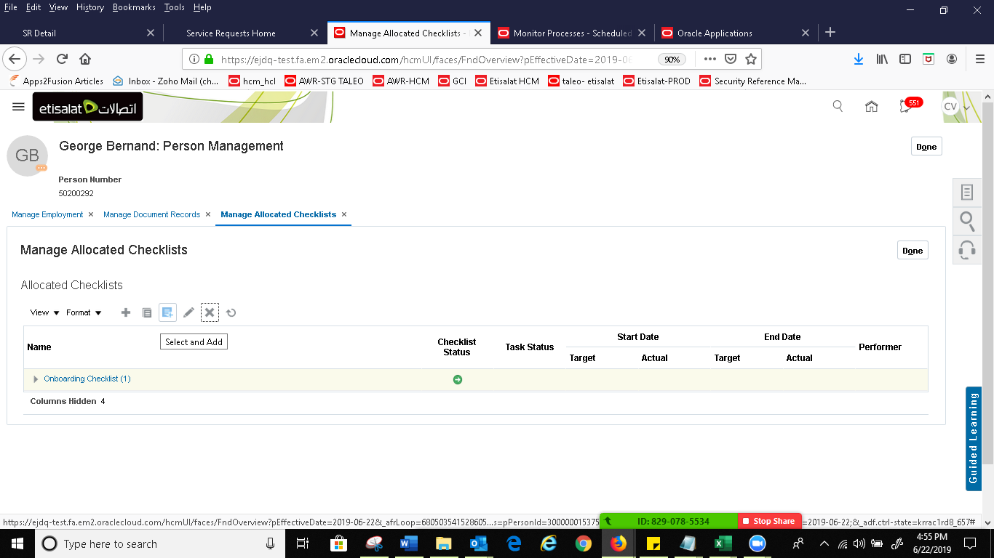
- Select category as Onboarding and click on search. Once the onboarding checklist appears, click on Allocate arrow icon to execute the checklist.

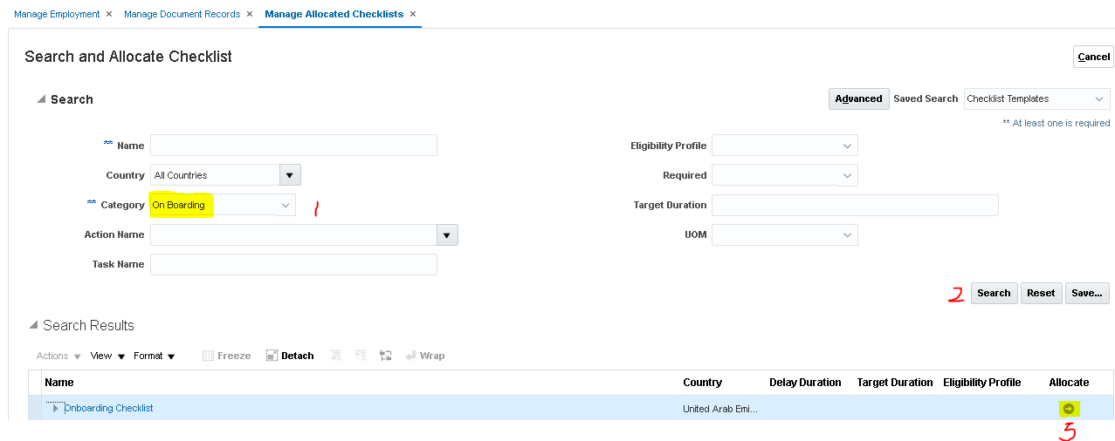
- Select current date to initiate the checklist with today’s date. Use a future date in case you want checklist triggering to defer until future date.
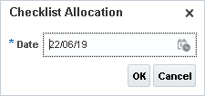
- The checklist will trigger emails(tasks) to the concerned team as per the below matrix. Please note that email will be triggered at common outlook mailboxes for each department.
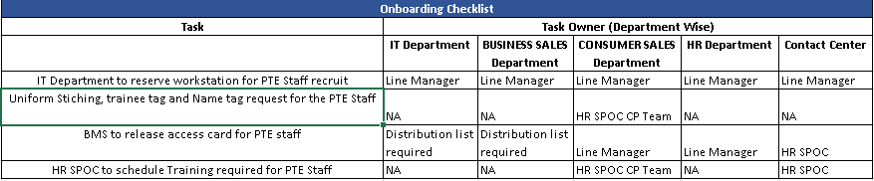
- The below email notification will be received by the concerned team(s) to initiate the onboarding tasks. A user can mark the task as completed or not applicable through email itself and the results will get updated in the system.
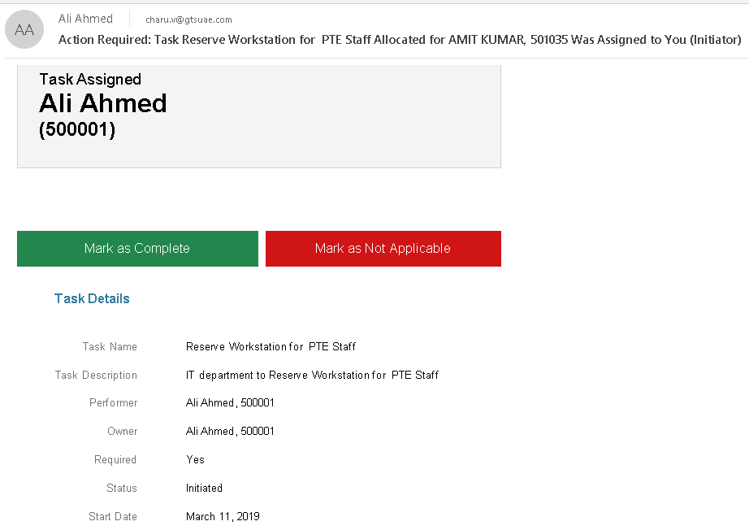
- If required, the status of the task(s) and checklist can also be monitored/updated by the HR SPOC.
Path: My Client Group> Person Management> Search for a Staff by name of EEID> Click on Orange arrow icon on the right-hand side corner of the staff name and then select Personal & Employment> Manage Allocated Checklist.
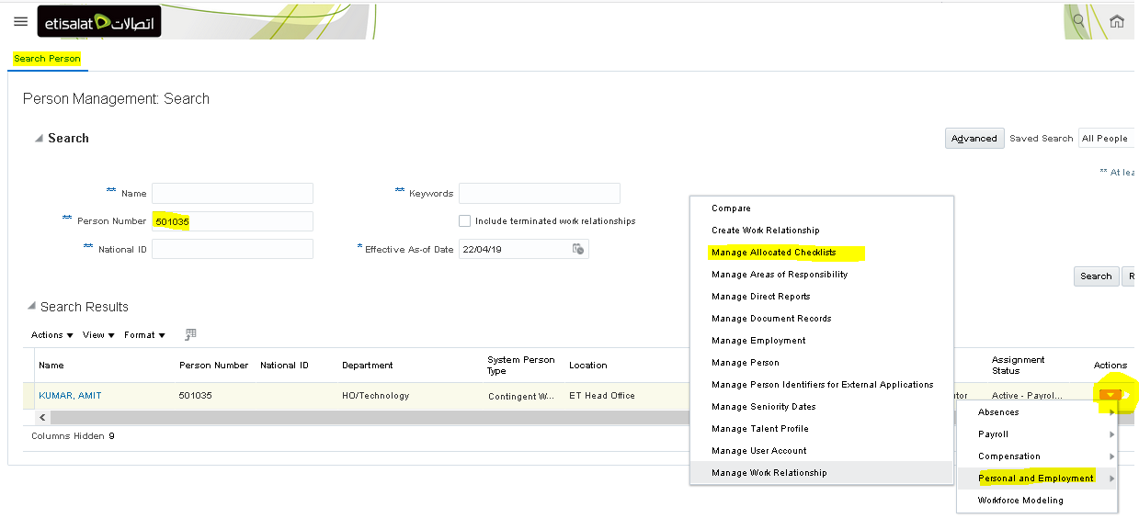
29. In the chklist, you can edit and update the status of the checklist and/or task(s), if needed. Once all the assigned tasks are completed, the status of the checklist automaticlaly chnages to Completed.
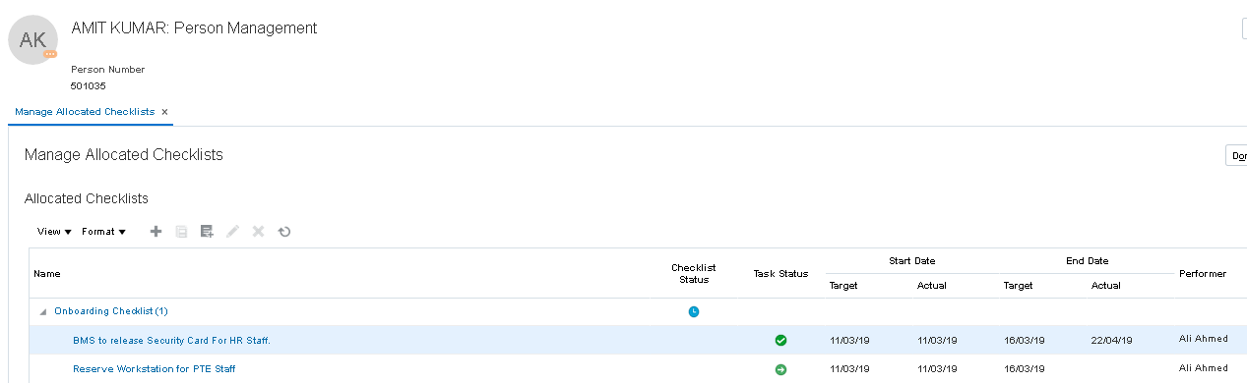

2. Personal and Assignment Data Management

HR will be able to update personal and assignment details of the Staff. All the changes will be date tracked.

A. Personal Information
- On the Home page, click the My Client Group > Person Management
- Search for the Staff by his/her name or Person Number.
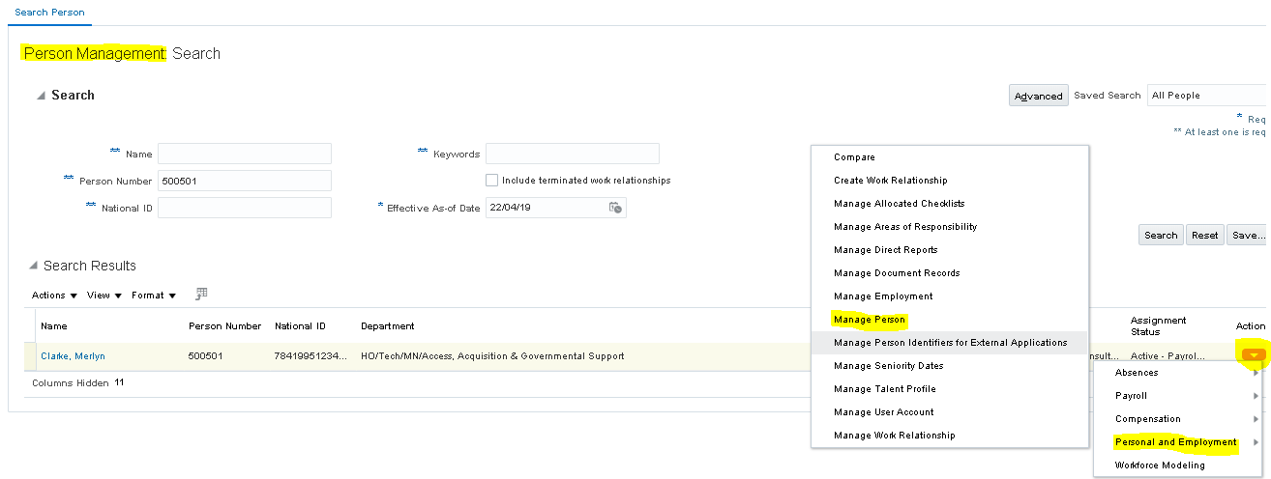
- Click the Personal Information option and the resulting window is shown below containing the personal information of the Staff. HR can update the personal details (e.g. Date of birth, religion, OLD PTE Staff ID, citizenship etc) accordingly.
Passport, visa details can be updated in Documents tab of Manage Person page
Please note that at the time of entering a date of birth of the employee in manage person page, we received the below warning message which can be overridden by the user. The minimum age limit in DOB is 18years at legal entry level.
Warning Message: "The person's age is below the minimum age 18 for this legal employer. Do you want to continue? (PER-1531241)".
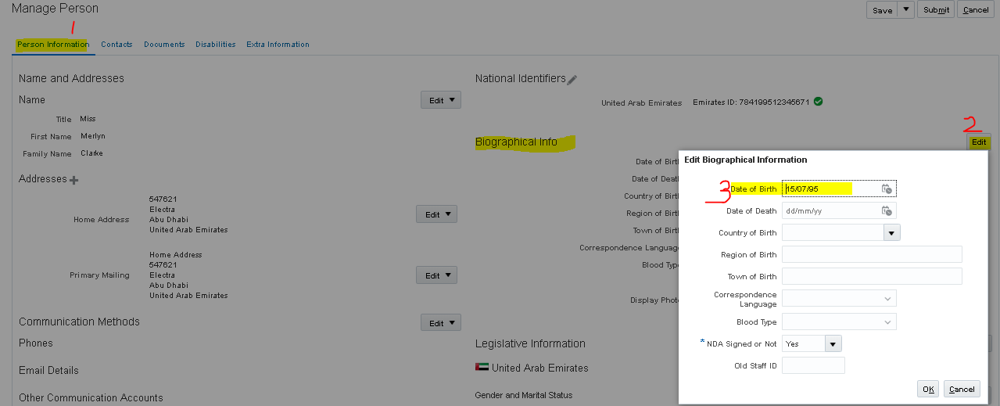

B. Assignment Changes

- On the Home page, select My Client Group> Person Management
- Search by Staff Name or Person Number
- Select the Staff name hyperlink to pull the record
- Select Update from the EDIT tab.
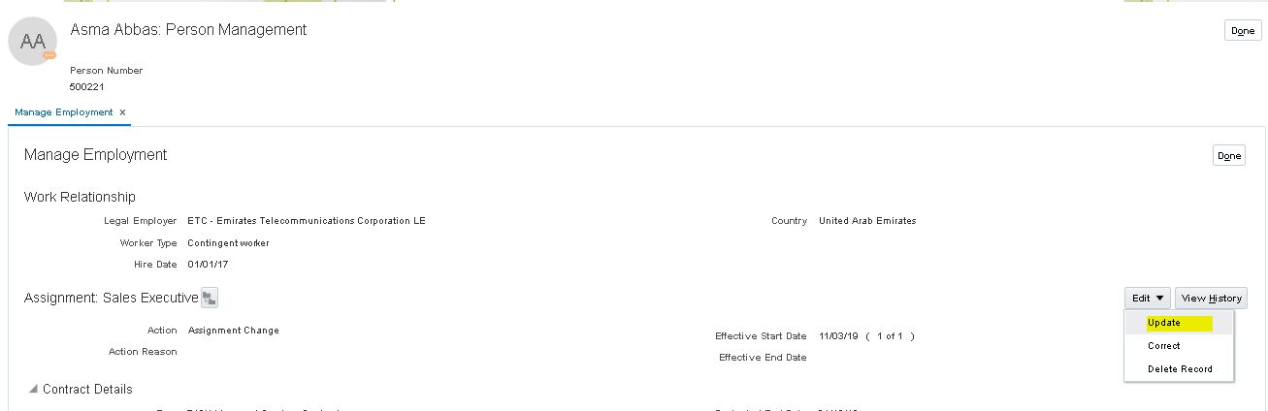
- Enter the date, action for the change.
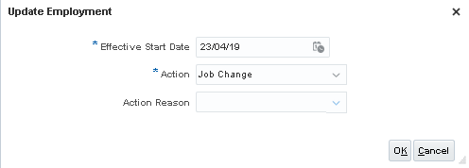
- Make the required changes in the Assignment like Department, position, job change and submit.
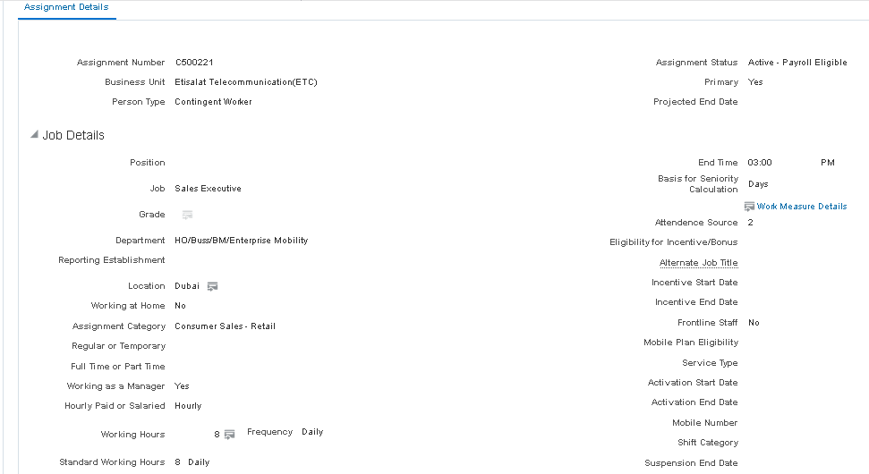

HR need to ensure that assignment record will have all the required information updated/provided correctly. These fields/data will have direct impact on the staff’s payment therefore it is mandatory to ensure that this data is correctly captured in the system.
- Attendance Source
- Contract Type (e.g. 702H Managed service (comprehensive etc)
- Hourly/Salaried/Daily
- Job
- Department
- Position
- Employment Status (Family/Bachelor) - Primarily needed for IT Staff
- Department Category
- PeopleGroup (this field will include Agency Name and Payment Category)
- Manager Name

C. Manage Document of Records

HR can view and add data in the Staff’s document of records. Document of records page has several placeholders to store data related to Staff.
- Expenses
- Insurance
- Bank Details
- Adhoc Payment
- Employee Requests (e.g. warning letters, disciplinary actions, Achievement, Award, Penalty, Appreciation, Warning)
- Onboarding Attachment(e.g. resume, photo etc)
- Work (e.g. Visa)
- Passport

- Click on My client group> Person Management
- Search for the Staff by name or person number.
- Select the Staff and click on Personal and Employment > Manage Document records.
- On the document records page, click on + sign
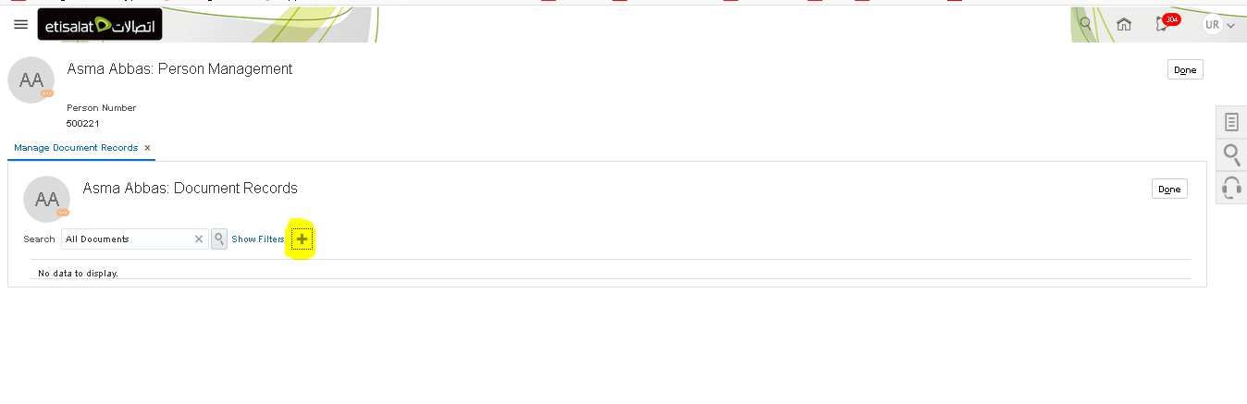
- Search via keyword ETC% and select ETC Employee Requests
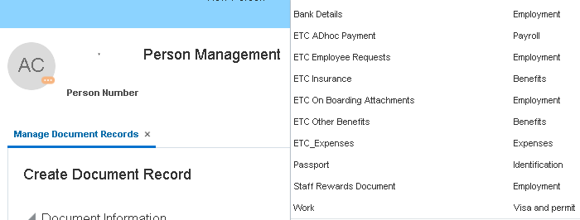
- Complete all the relevant details like request type (e.g. Disciplinary Actions), Comments, attach document as a proof and Submit.
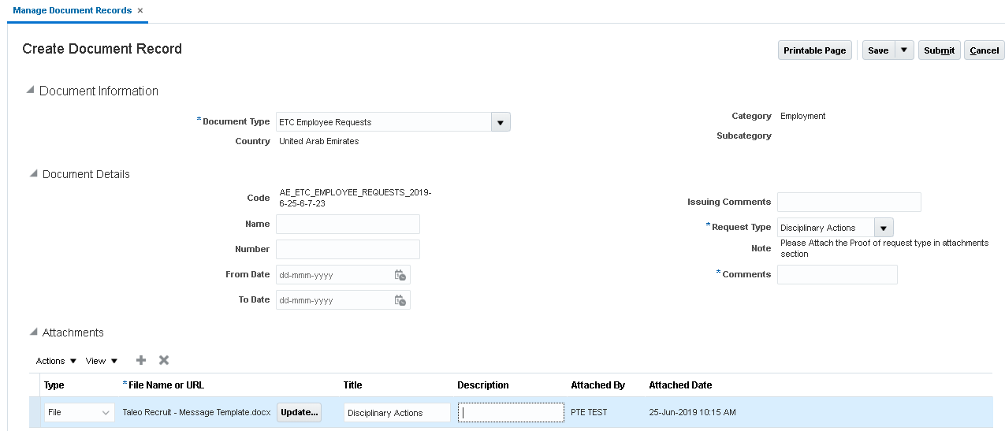
Important Points:
- Document Code while uploading Documents will be auto generated and non-editable by the user
- Bank Details:
- When entering bank details, following validations are in place. IBAN No must be 23 characters long and must have the given format AE123456789012345678901. There shouldn’t be any space and “AE” must be in capital letters.
- Atleast one attachment is mandatory to attach relevant proofs like NOC letter

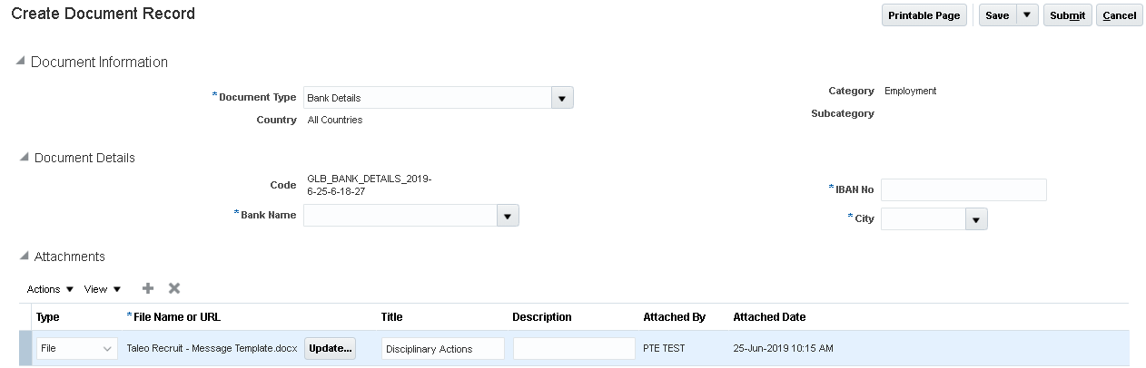

- Payment Period field will pre-populate with the current date and will be read only for all the users.
- Any document attached by the HR or other user (e.g. Staff, line manager, agency etc) will follow the approval process defined for that document.
- The below documents once uploaded by the HR, will follow the approval rules.
Process Name | 1st level Approver | 2nd Level Approver | FYI Notification
Benefit Requests | Line Manager | HR SPOC | Agency
Expenses | Line Manager | HR SPOC | Agency
Bank Details | Agency | NA | NA
Document Records (work permit, visa etc) | Line Manager | HR SPOC | Agency

D. Work Schedule management and Assignment

Each Staff must be assigned to a work schedule as this has direct impact on absences and timecards.
A default work schedule of 7am to 3pm, 5days per week is already assigned at a legal employer level. However, for the staff working in night shifts or 6-day work schedule must have work schedule assigned.
- Click on My client group> Person Management
- Search for the Staff by name or person number
- From the Tasks list, select Manage Work Schedule Assignment from Absences section.
- Select the required work schedule from the list, change the Start and End dates (if needed)
- Select Yes in the Primary
- Click on Review and then Submit the changes.
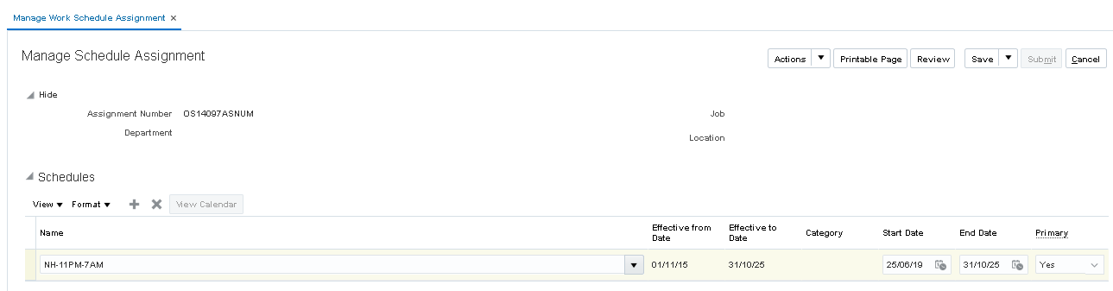

E. Termination

Terminating a Staff work relationship involves the following process:
Process Description
- Click on My client group> Person Management
- Search for the Staff by name or person number.
- From the Person Management Window, from the Tasks pane select Manage Work Relationship from the Personal and Employment section. The Resulting window is shown below:
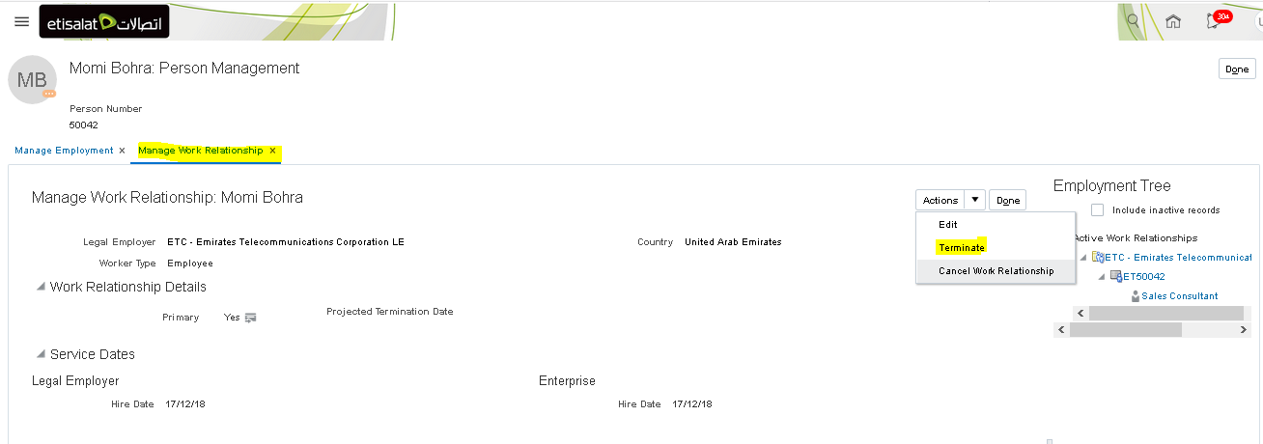
- As shown above, click Actions drop down option and select Terminate option.
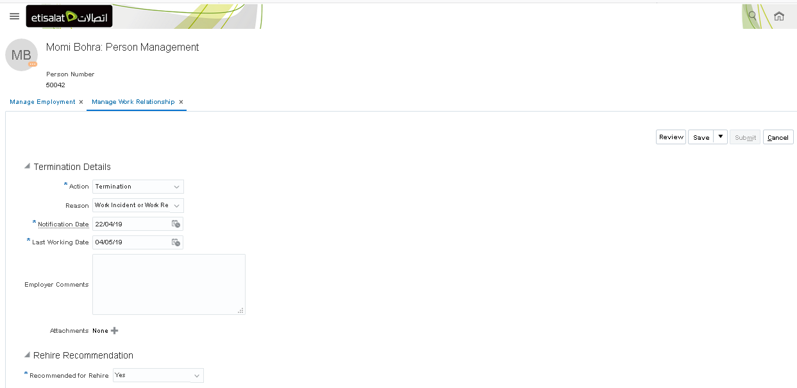
- Fill in the relevant details, review and submit. Warning with the request will be submitted. Do you want to continue? (HRC-1035163). Click YES to complete the process.
- Once the termination is processed, a checklist will be triggered for the stakeholders as per the below list.
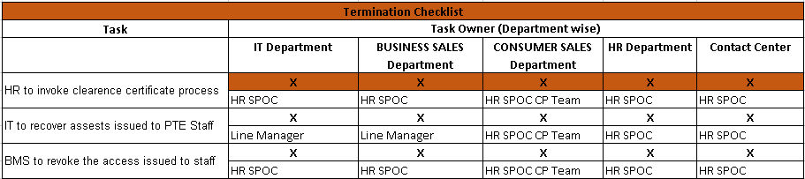
- HR SPOC can track the termination checklist for the staff through Manage Allocated Checklist page from the TASKS bar.
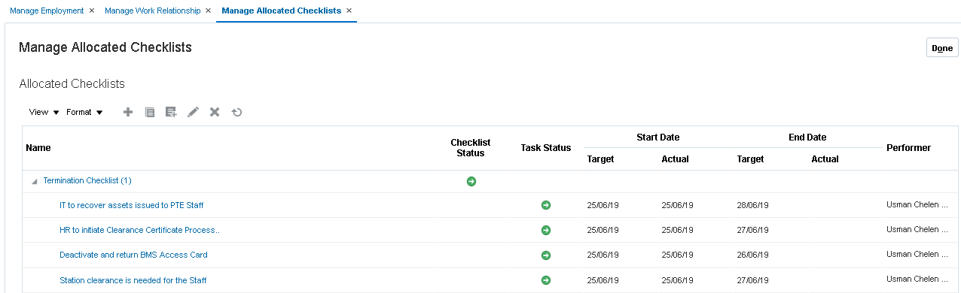
- The below email notification will be received by the concerned team(s) to initiate the termination tasks. A user can mark the task as completed or not applicable through email itself and the results will get updated in the system. Similarly, they can update the status in the system directly.
- To update the task(s) directly in HCM, select the concerend task and click Edit
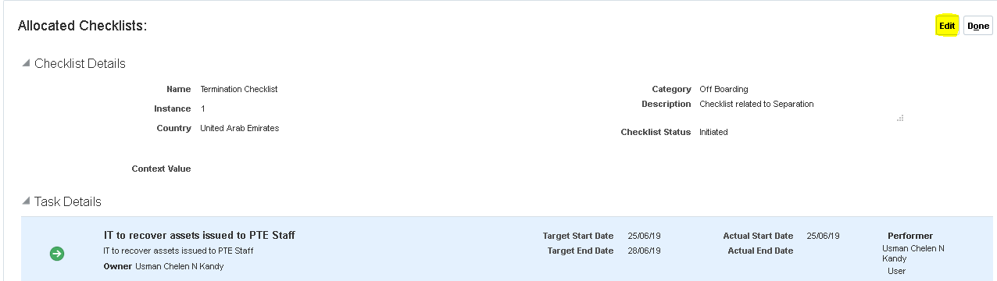
- In the task details section, click on pencil icon to edit the task.
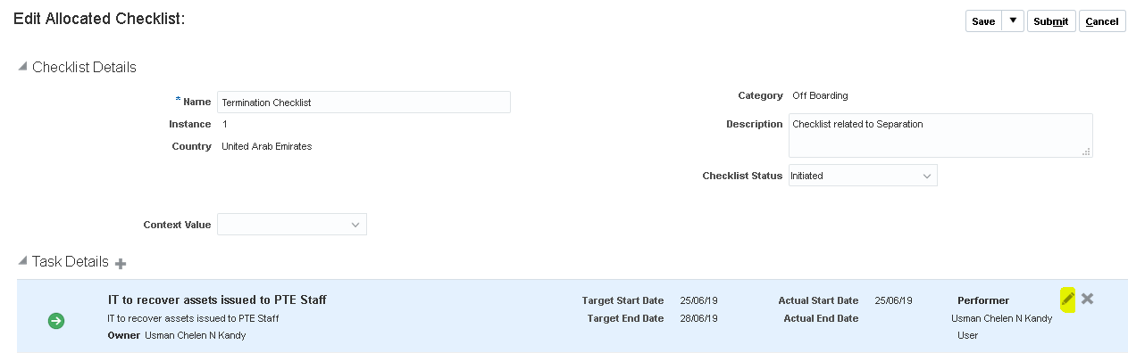
- Change the Status to Completed, Inprogress etc as per the requirement.
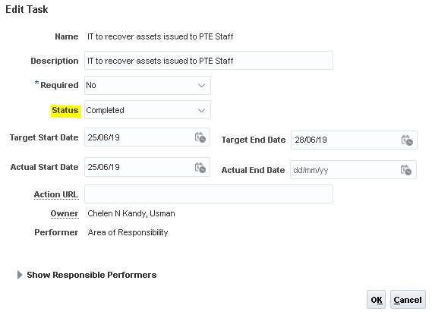
Notes:
- HR SPOC can process resignation for the Staff with retro, current and future effective dates. However, from the Staff self-service, Staff can only submit resignation with past date.
- Resignation will show the given reasons: Other, Better Opportunity, Personal Reasons.
- A Resignation checklist will trigger, when a resignation is submitted for the Staff.
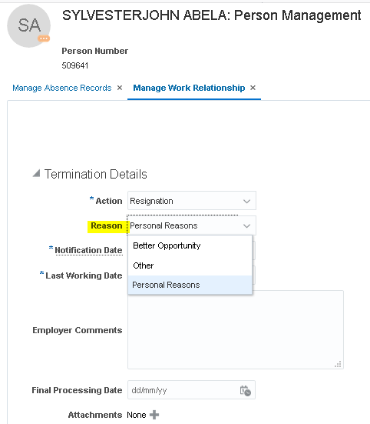
- Once a staff is terminated, an FYI alert will be triggered to the concerned agency on an overnight basis.
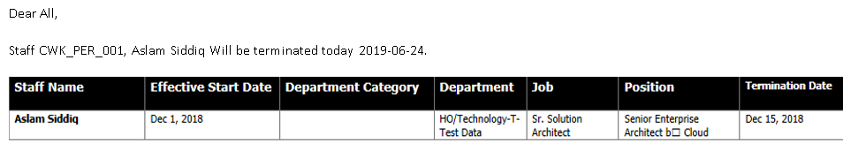

F. Suspension Process

- Click on My client group> Person Management
- Search for the Staff by name or person number which will open Manage Employment page.
- Click on EDIT>Update
- Select effective date, Action as Suspend Assignment and click OK.
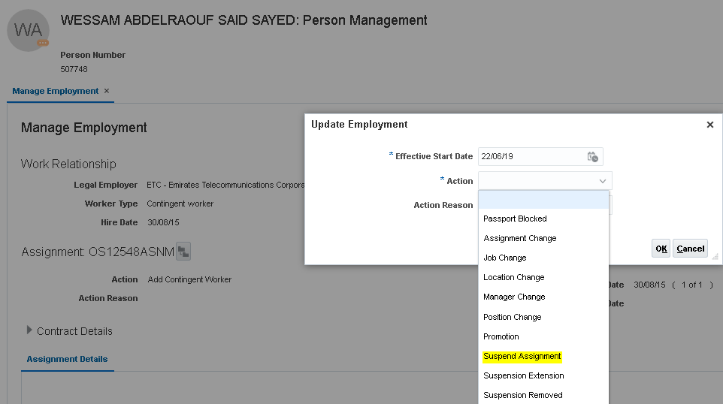
- Enter Suspension End Date and Assignment status to Suspended-No Payroll in the field.
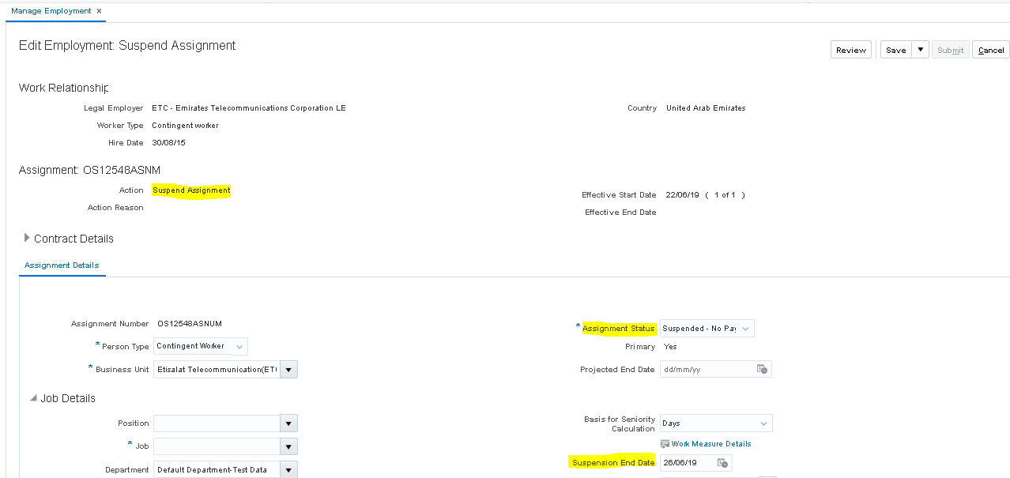
- Click on Review and then Submit button to save the transaction.
- A checklist will trigger for the concerned users.
Please note the following:
- If suspension needs to be extended, user can select Suspension Extension in the ACTIONS field (as shown in point#4)
- If suspension needs to be removed, user can select Suspension Removed in the ACTIONS field (as shown in point#4)
- Suspension Assignment and Removal triggers a checklist for the different teams as per the below matrix.
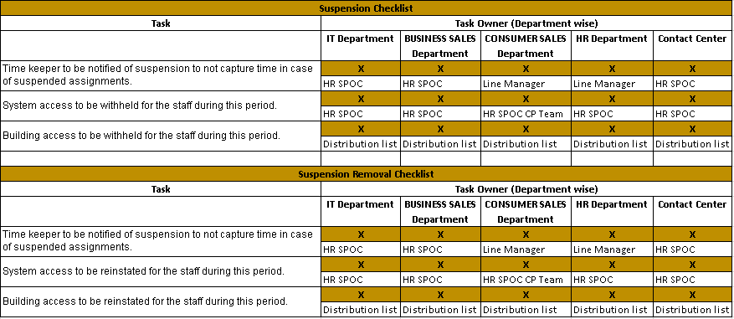

G. Absences Records

There are various types of absences which can be submitted by the Staff. These leave types will be visible for the staff(s) as per their eligibility criteria.
Leave Type | Eligibility to apply via HCM
Annual Leave | Applicable to all the Staff
Sick Leave | Applicable to all the Staff
Maternity Leave | Female Staff
Child Nursing | Female Staff
Hajj Leave | Staff based on Islam Religion
Compassionate Leave | Applicable to all the Staff
Unpaid Leave | Applicable to all the Staff
Training Leave | Applicable to all the Staff
Duty Travel | Applicable to all the Staff
Compensatory Leave | Applicable to IT Staff
Uncertified Sick Leave | Applicable to Staff in 702H Special Contract 1 and 2

- Click on My client group> Person Management
- Search for the Staff by name or person number
- From the Task list, select Absence records to review the absences details of the Staff.
- A HR can also apply for an absence on behalf of the Staff, if needed.
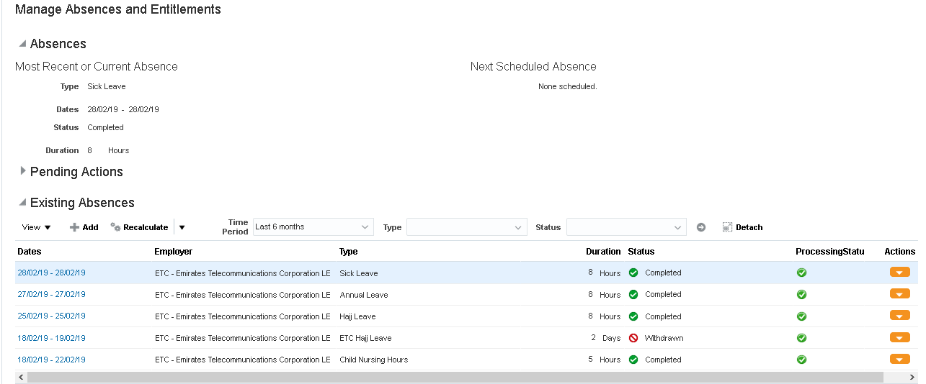
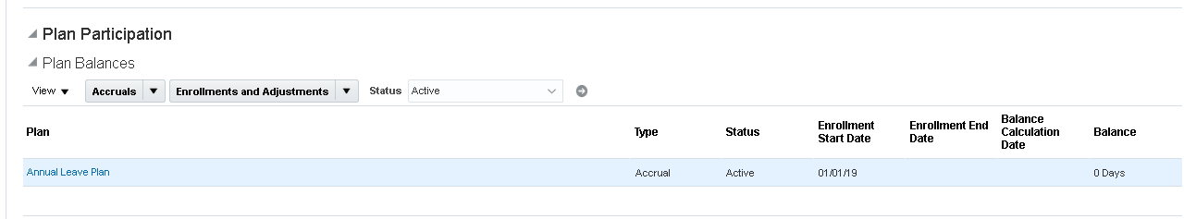

All the absences submitted by HR SPOC will be auto-approved.
Please note the following:
- As per Oracle, we can’t make Attachment mandatory at the time of applying for a sick leave. Therefore, a warning message on the page to attach certificate at the time of applying for a sick leave.
Please note the following:
- The absence request when entered by the Staff through self service will follow the below approval rules.
Absence Approval process for CCC- Shifts:
- When leave type is Annual and Sick leave: 1st approval Line Manager > 2nd approval WFM group > FYI to Agency
- When leave type isn’t Annual and Sick leave: 1st approval Line Manager > FYI to Agency
Absence Approval process for CCC- Support:
- 1st approval Line Manager > FYI to Agency
Absence Approval process for Other Departments (IT, HR, Consumer Sales, Business Sales):
- 1st approval Line Manager > FYI to Agency
- Once the leave of absence is “Approved” by the Line Manager, it will get committed/completed in the system.
- The FYI alerts which triggers for the agency does not require/expect any action on them, as they are just informational alerts.

3. Staff Hire/Re-Hire directly in HCM

This process is followed when the Staff is re-hired/hired directly in HCM. This process should only be followed in case of exception or specific business requirement.
- Click on My client group> New Person
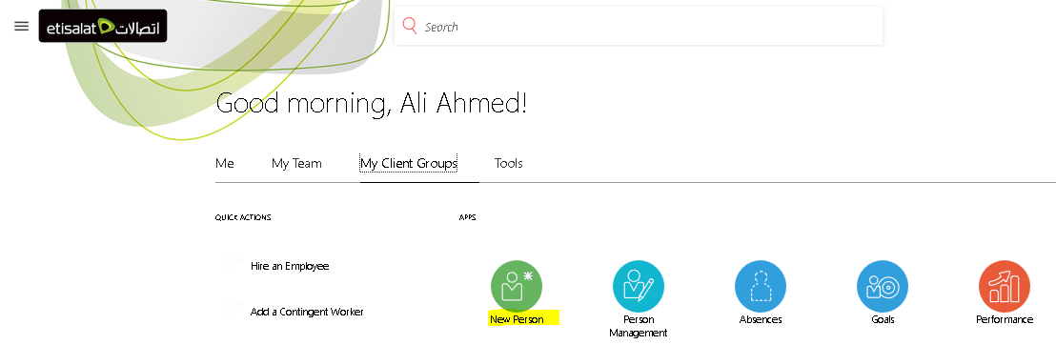
- From the New Worker in process window, from the Tasks pane select Add a Contingent Worker. The Resulting window is shown below:
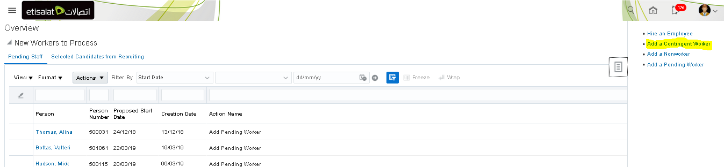
- On Add a contingent worker, user can enter below details
  - Placement date (i.e. Hire Date),
  - Legal employer,
  - worker type = Contingent Worker(default),
  - First and Last Name
  - Gender, Date of birth, NDA Signed or Not and other relevant details
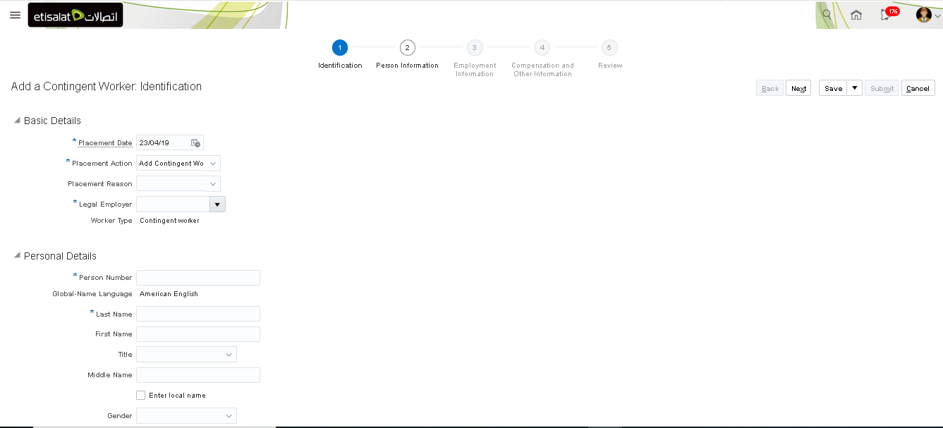
- In the Personal Information page, enter the address details like Address line1, Emirates information. Click Next
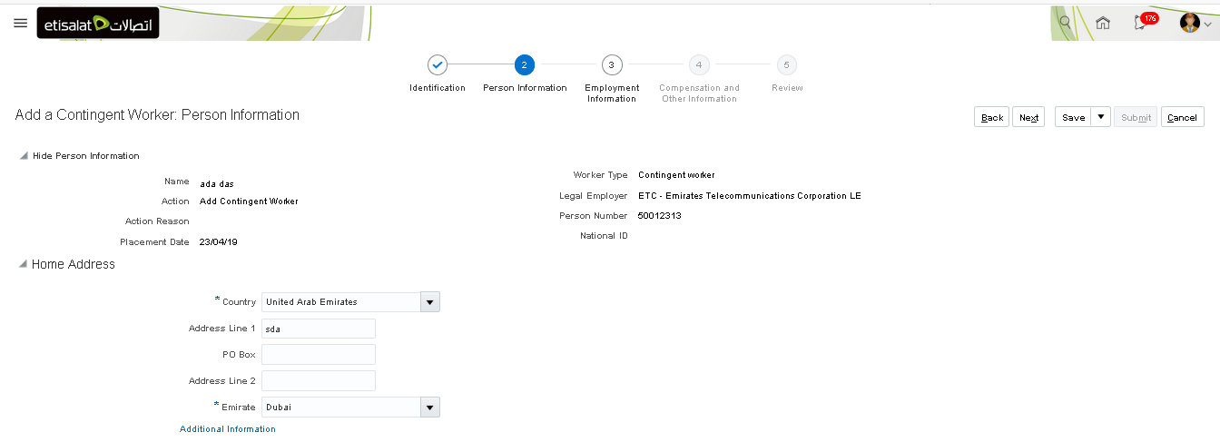
5. In the employment information page, user can update Contract details, Assignment and Manager details. The information provided in this page is very crucial. Click Next.
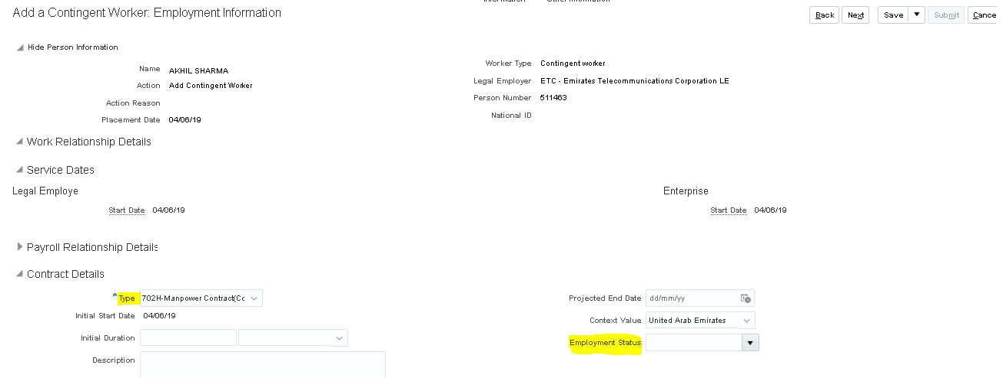
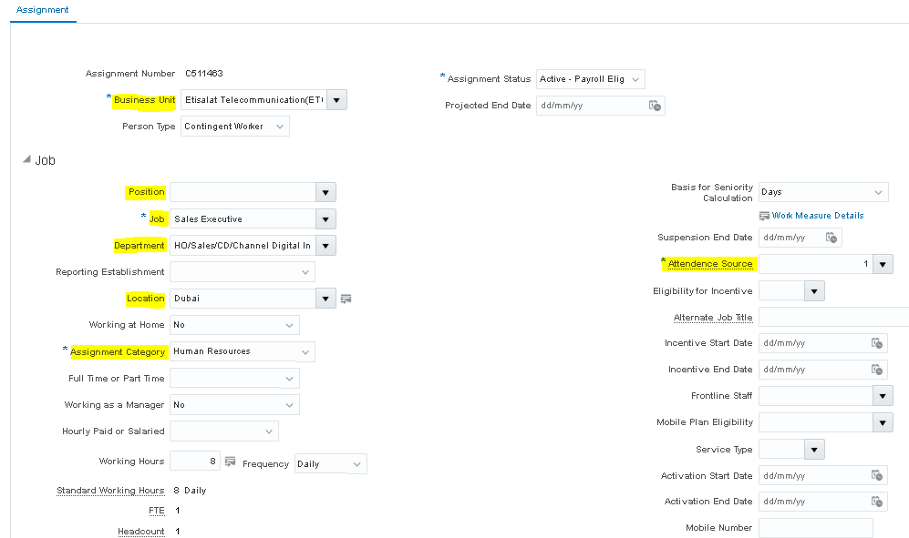
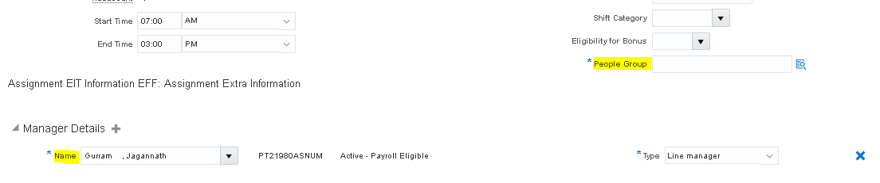
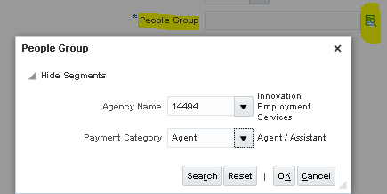
6. In the next page, provide the salary/compensation details.
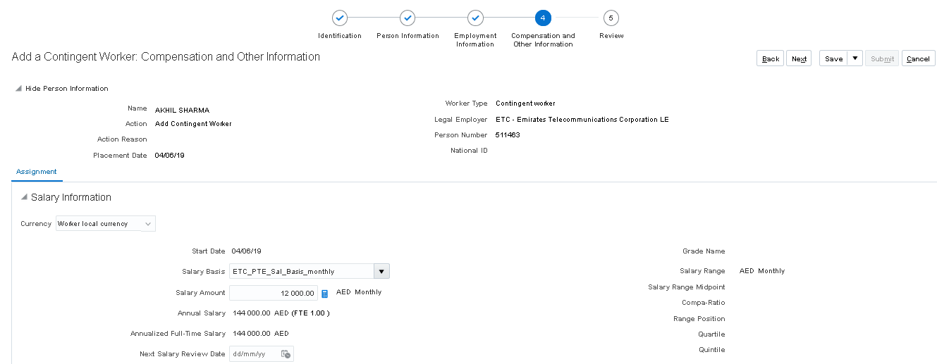

- Click Review and then Submit button to submit the Staff profile.
- If you go to My Client Group> Person Management and search for the staff using person id(i.e. employee id) or name. You can pull the record of the Staff and take additional actions, if needed.

4. Changes to Assignment Action/ Action Reason

If HR wants to add/remove or end date/change any action or action reason for the processes. Example: Passport Block action to be added in the Assignment change page.
- On the Home page, click on “Others” tab and then select Setup and maintenance
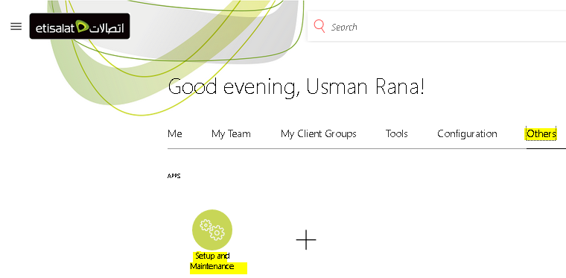
- On the setup page, select Workfornce Deployment, search with keyword as “action” (not case sensative) and then select Manage Actions under functional are (Workforce Information).
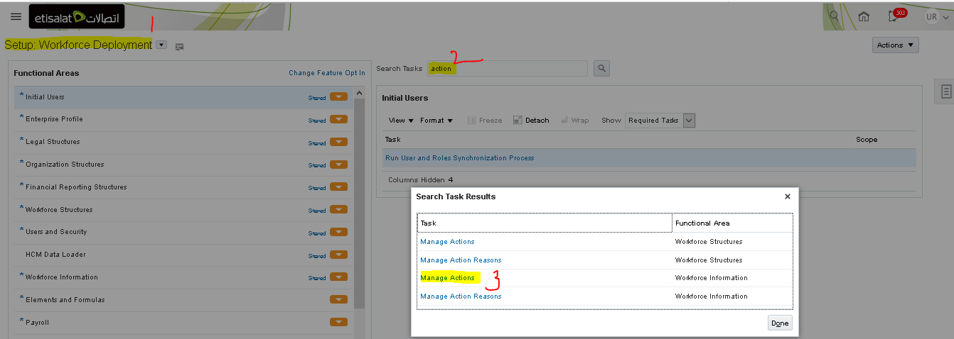
- To Add a new action in the list of actions used under assignment, termination etc processes, click on + sign to add a new blank record.
Please note to validate the exisiting list of actions to ensure no duplication will happen, before adding any new action(s).
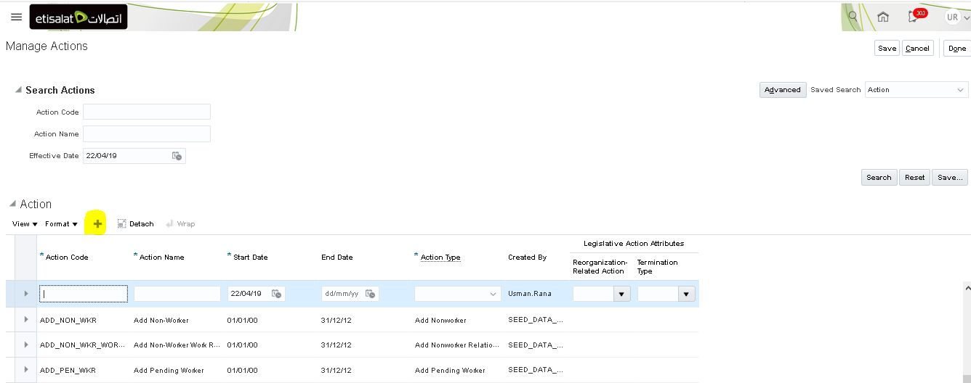
- Enter the below details:
  - Action Code: Name of the code. Please ensure to add underscore (_) between inplace of space between the letters. There should be no space in the code. E.g. BLOCK_PASSPORT
  - Action name: Name of the action which you want to add in the Assignment page list
  - Start Date: 01-01-1900
  - End Date: 31-12-4712
  - Action Type: Appropriate action type (e.g. Change Employment). Please note we cannot create a new action type. Only seeded/Oracle delivered actions can be used.
  - Reorganization Related Action: Select Yes or No (to be used only when action is related to reorganisation)
  - Termination Type: Voluntary or Involuntary. (To be used only if you have created an action related to termination).
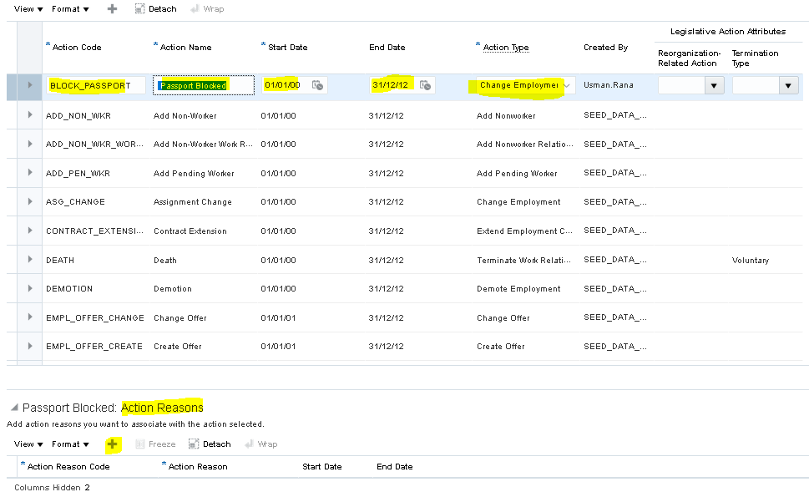
  - Once the action is created, you can add/create corresponding Action Reason from the same page.
    - To add Action Reason from the existing list
      - Click on + sign and then No in the warning message received.
      - This will pop up another window to select the Action reason from the list. Select the appropriate reason and save the record.
    - To Create a new Action Reason
      - Click on + sign and then YES in the warning message received.
      - This will pop up another window to create an Action reason. Enter code, reason, start and end as mentioned above and click OK.
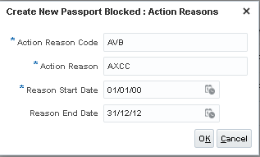

5. New Agency/Vendor Creation Process

- HR SPOC will create Agency users in IDM as a vendor.
- IDM will create agency’s account in Fusion HCM using webservices
- Once account gets created in HCM, IDM team will further assign/add roles related to agency as per the user roles configured in HCM.

Please note: Incase, an access is needed for a new agency outside the below list, HR SPOC would need to inform IT Admin team to create the role in HCM so that it can be further assigned by the IDM team. Once the data role is ready, IDM team can create the user account and assign new data role specific to the new agency.
S.No | Data Role
1 | ETC Al Mansoor Enterprises LLC
2 | ETC BITECH INTERNATIONAL LLC
3 | ETC DICE TEK LLC
4 | ETC Dulsco LLC
5 | ETC Emirates Technology Solutions (L.L.C)
6 | ETC First Select Employment Services
7 | ETC GULF TESTING FACTORY SERVICES GTFS LLC
8 | ETC Innovation
9 | ETC OMNIX
10 | ETC PENTA FACILITIES MANAGEMENT SERVICES (L.L.C)
11 | ETC Reach Employment Services LLC
12 | ETC STAR Services LLC
13 | ETC TECHVISTA SYSTEMS

6. Delegation of Access through worklist

- Click on bell icon on the Home page and then Show All
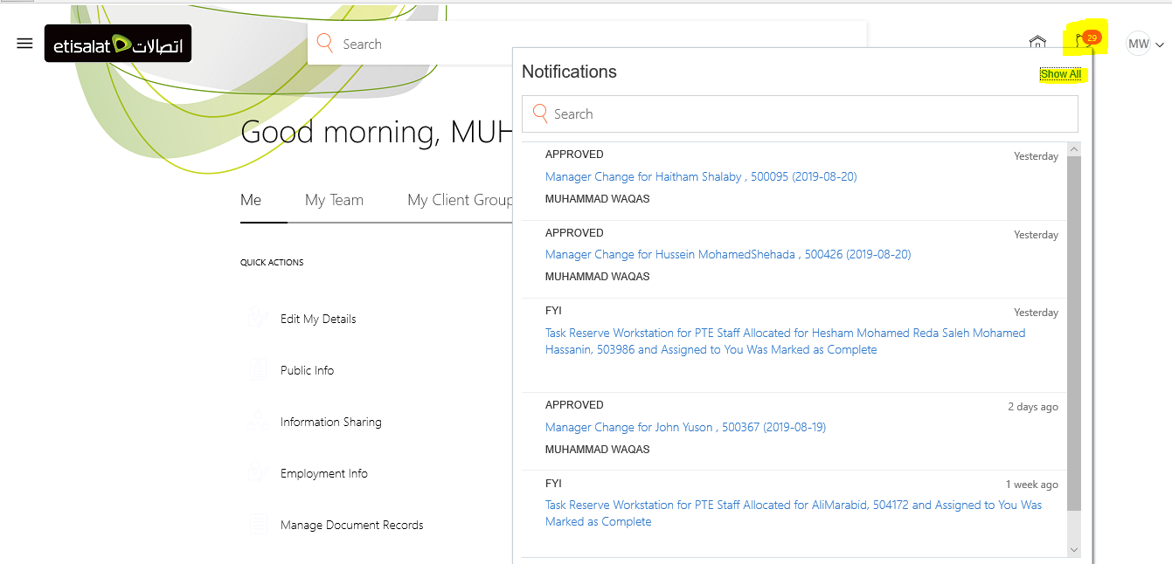
- Click on Worklist

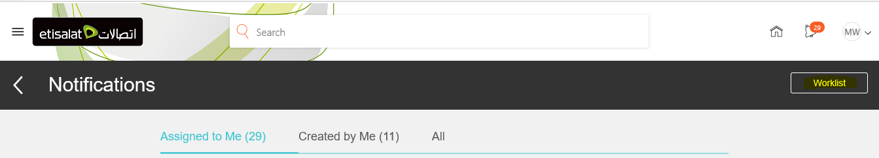

- On the next age, click on your name and then select Preferences from the drop down.

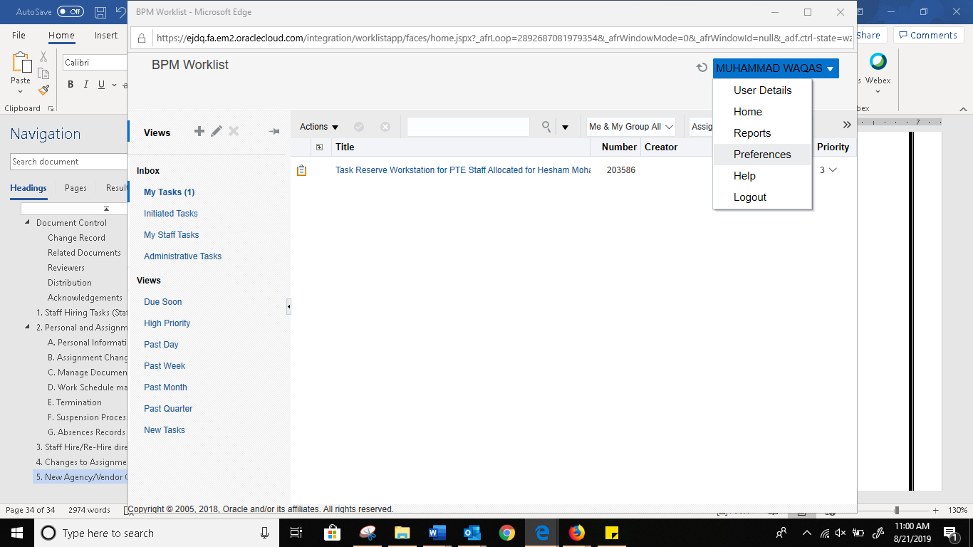

- In the next vacation rules page, enter the below details and save.
- Check Enable vacation period checkbox
- Enter start and end date of delegation
- Select Delegate to radio button
- Search and then select required person to delegate your tasks to
- Click on Save to save the changes.

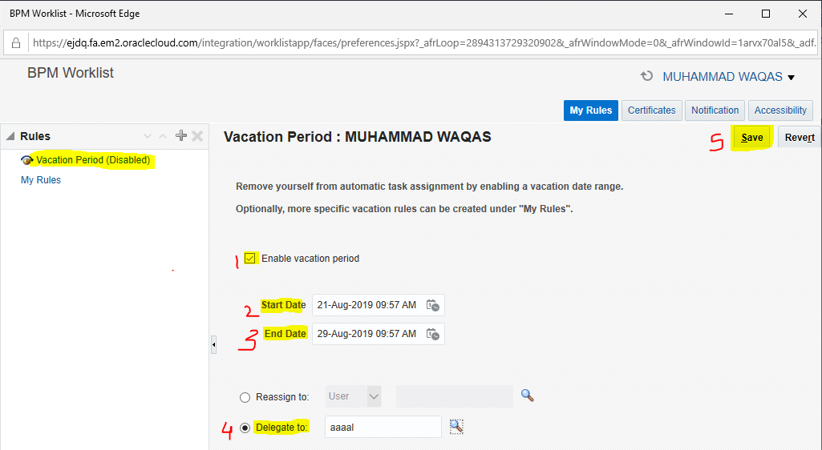

As per the delgation rules, the concerned person o whom delegation has been granted will receive tasks or email and notifications for the targeted time frame.

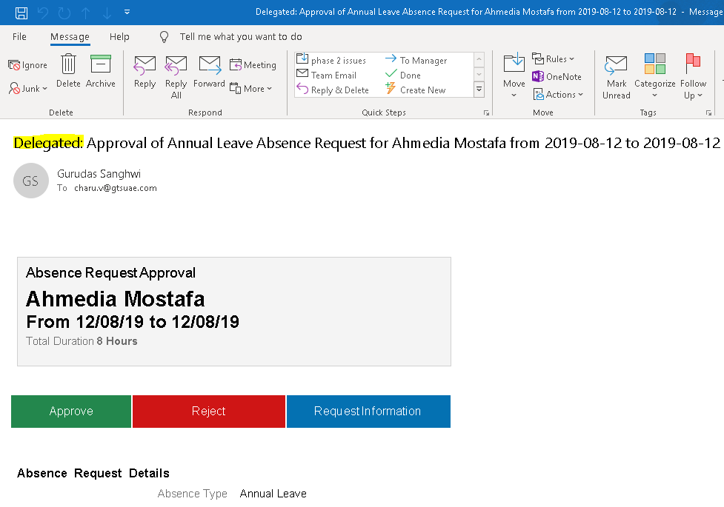

7. HSDL upload

From HSDL functionality HRSPOC will be able to upload transaction like Ad hoc payments and salary details in bulk.
Navigation:
My client groups > Data Exchange > HCM Spreadsheet Loader > Run Spreadsheet Data Loader > search for ‘ETC Adhoc Payments Upload’ > then check on name of template ‘ETC Adhoc Payments Upload’ and follow below screen shots.

Click Enable Editing
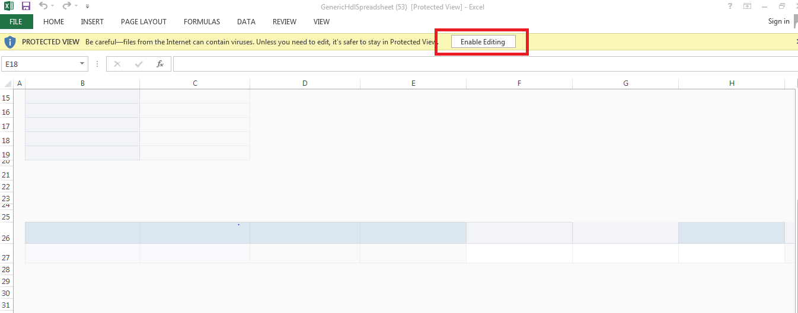

Click Yes
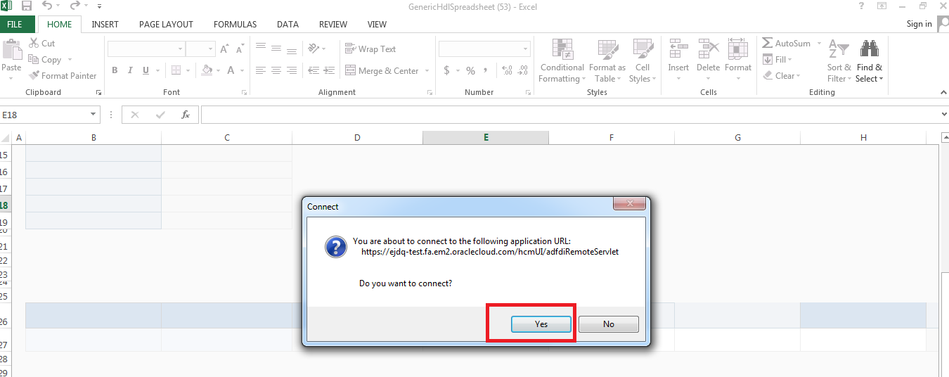

Login using SSO.

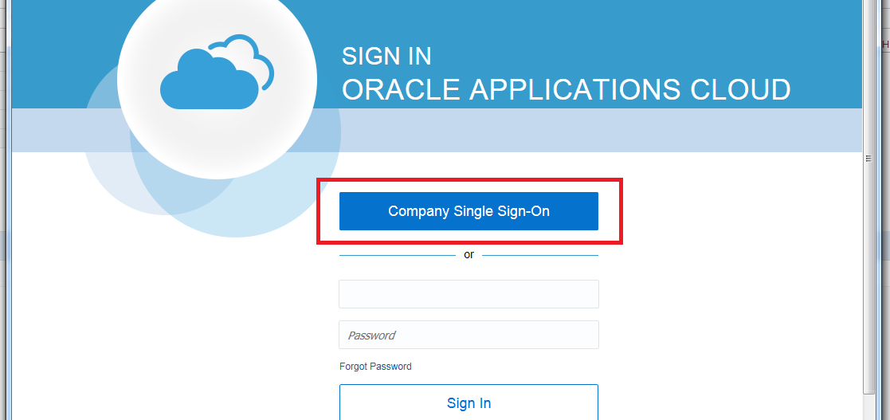

Go to Spreadsheet Leader tab

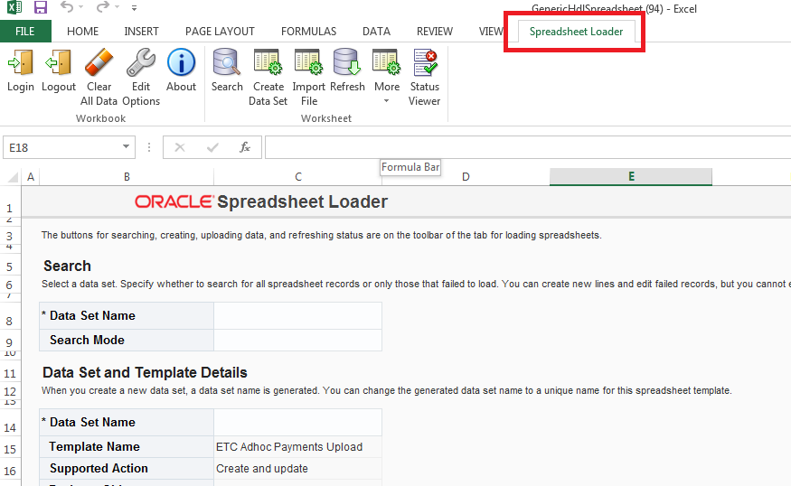

Then click Create Data set
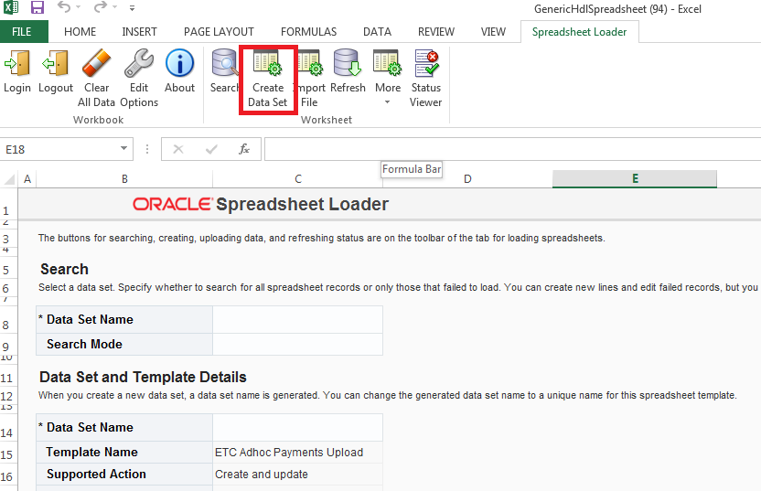

Then click OK
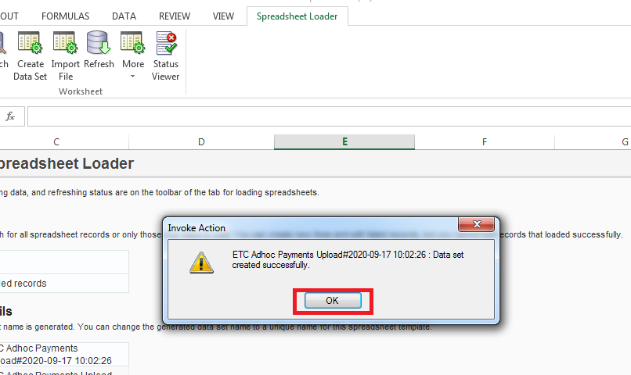

Then click on REVIEW tab and Unprotect the sheet

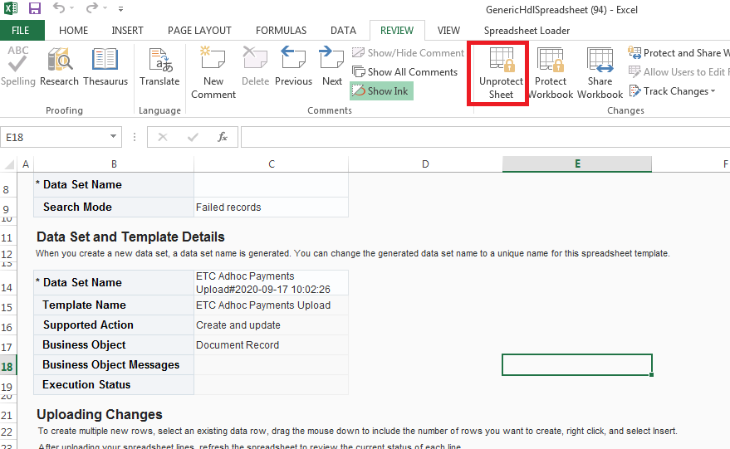

Then insert Line as many as required
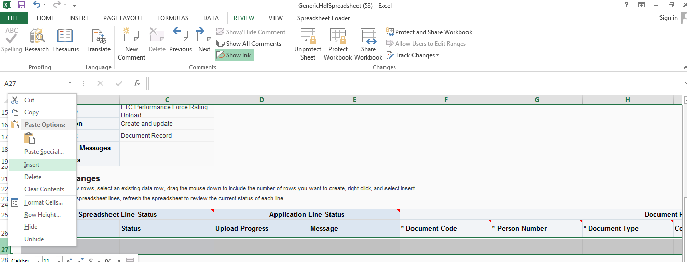

Then fill the data as below
Document Code: Free Text enter as per your requirement e.g. Bonus for month of Sep 2020
Document Type: ETC ADhoc Payment (auto populated don’t change)
Country: United Arab Emirates (auto populated don’t change)
Context Value: ETC ADhoc Payment (auto populated don’t change)

Fill the data below is an example

Once data is filled click on Spreadsheet Loader and click Upload
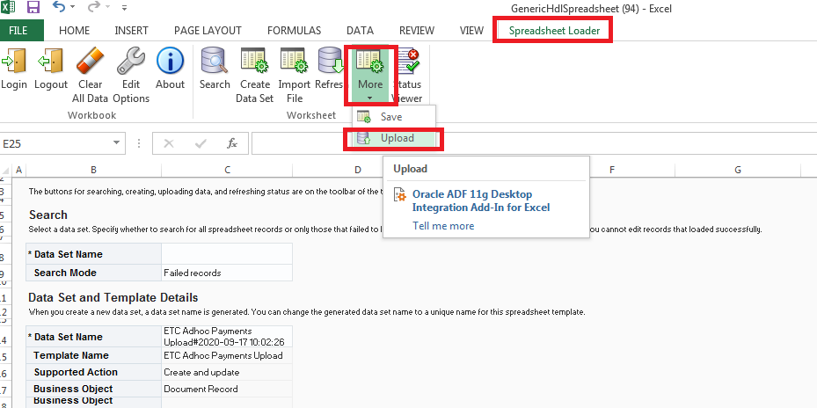

Make sure both below checkbox are checked and then click OK
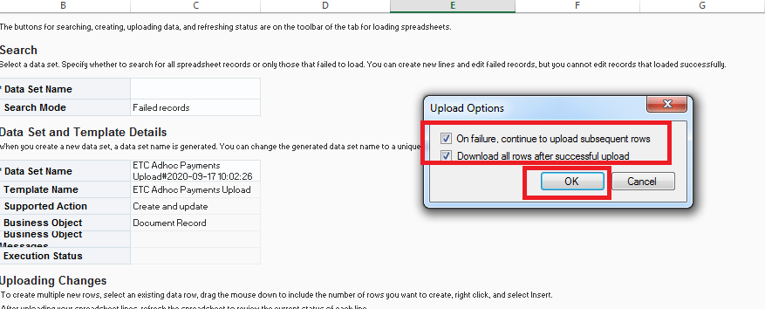

Then click OK again
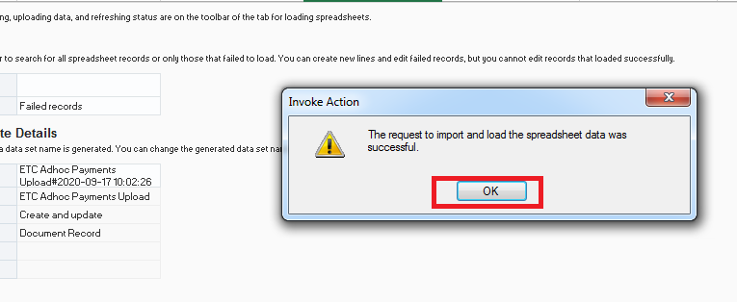
Then click refresh button available in spreadsheet
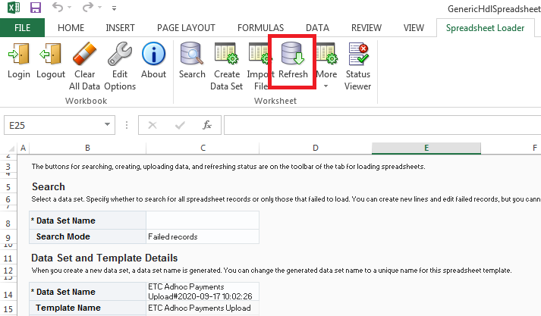
After refreshing for little time system will let you the status of your upload in spreadsheet itself as below, you can go to staff record and cross verify your upload changes
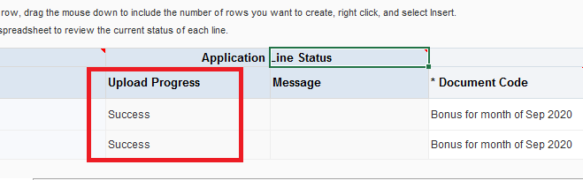

Note: if you are not able to open spreadsheet loader in your machine please contact operation admin team for assistance. And similar way you can also upload salary details for staff below is the name of that HSDL.
Salary upload HSDL name: ETC Salary Details Upload

Administration of Consumer Sales Department User for Specific User Tasks
There is a new Job Role “ETC CS HRSPOC Restricted” for administration of Consumer Sales Staff specifically for changing following details by HRSPOC Of consumer Sales Department
- Change or Entry of Location
- Change or Entry of Manager
- Change of Entry of Attendance Source
To enable administration of following activities the Job Role to be assigned to user is
“ETC CS HRSPOC Restricted”

Change or Entry of Location
After assigning of Job Role “ETC CS HRSPOC Restricted” , following is the navigation for change or Entry of Location by HRPSOC
Navigation :
- From "Home Page"
- Click on "Home" Icon on Top Right

- Click on Options "My Client Groups"
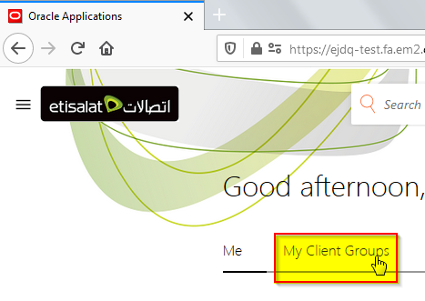

- Click on link “Change Location”

- A new “Change Location” page opens up, search for the Staff Name or Number and select from the drop down for selection
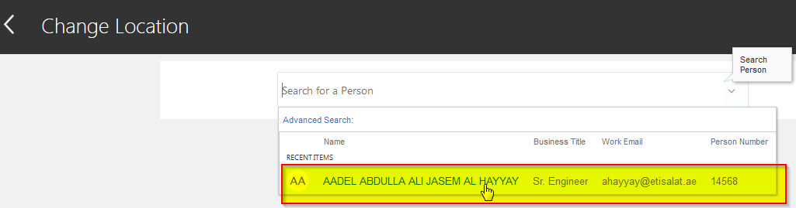
- Enter “Location Change Start” Date and click on “Continue”
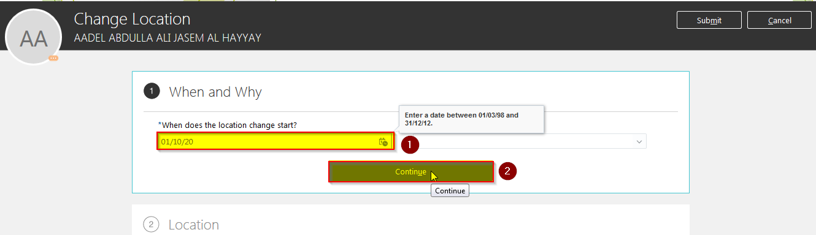
- Enter “Location” by entering location details and selecting from dropdown
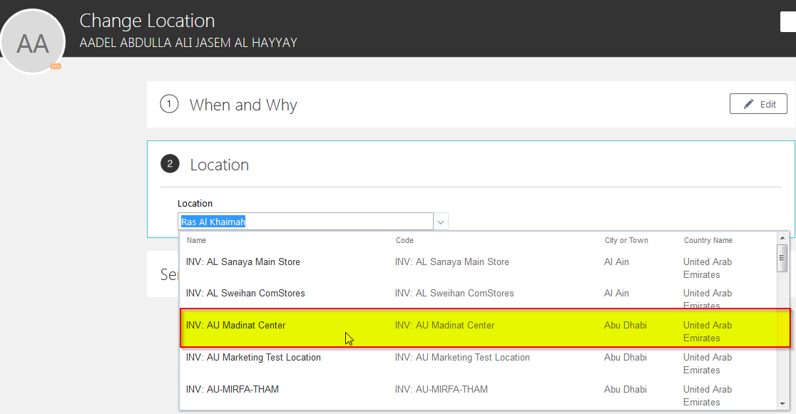

- Finally Click on “Submit” Button, this step closes the change Location process.
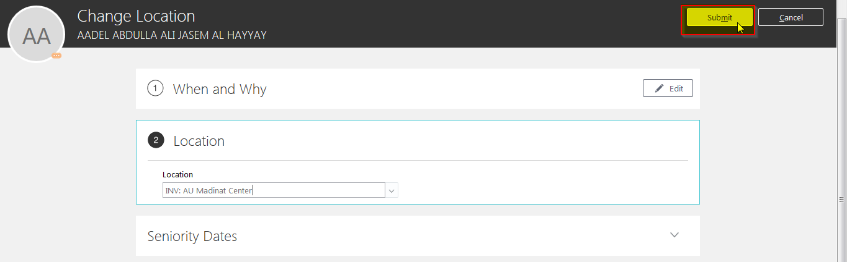

Change or Entry of Manager

After assigning of Job Role “ETC CS HRSPOC Restricted” , following is the navigation for change or Entry of Manager by HRPSOC
Navigation:
- From "Home Page"
- --> Click on "Home" Icon on Top Right
- --> Click on Options "My Client Groups"

- --> Click on link “Show More”

- --> Click on link “Change Manager”
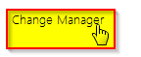
- --> A new “Change Manager” page opens up, search for the Staff Name or Number and select from the drop down for selection
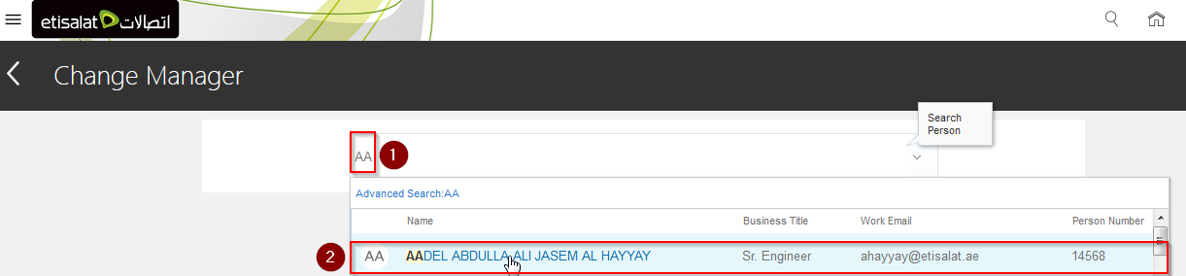

- --> A new page opens up, enter the “Manager Change Start” Date and click on “Continue” button
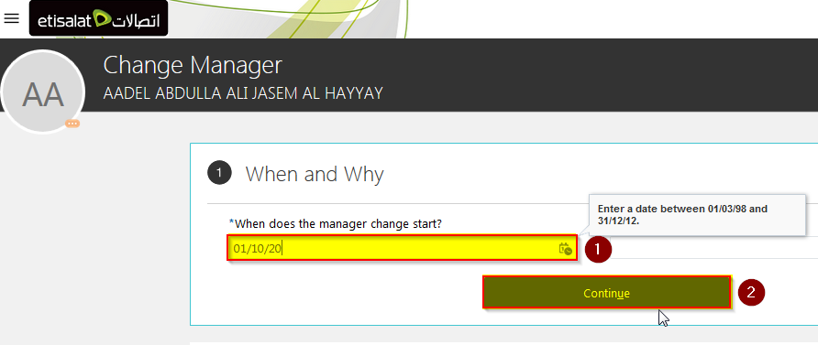

- --> Click on “Edit” icon or “Add” icon as per requirement, we choose the edit option
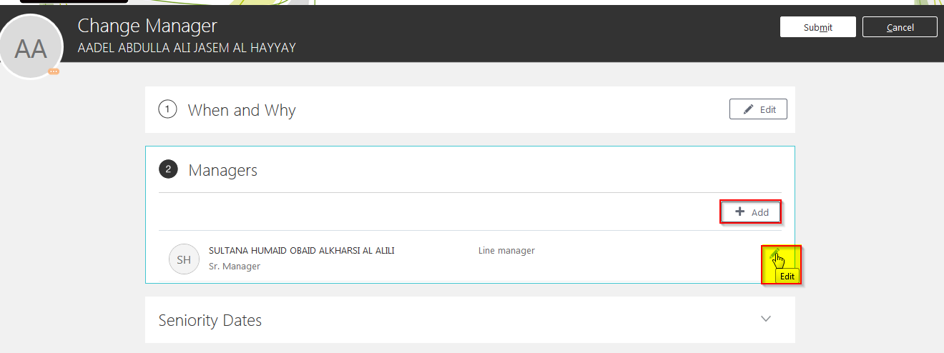
- --> Enter name of changed supervisor and choose from the drop down as in the snapshot below

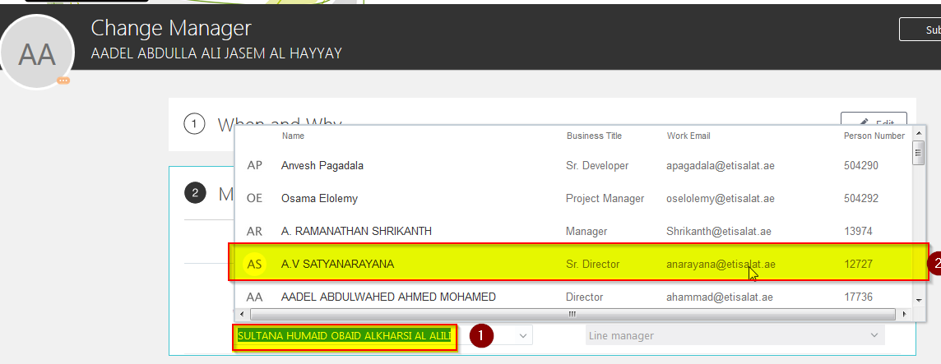

- --> After selection of supervisor from the drop down as in the snapshot below, click on “Submit” Button, this closes the “Change Manager” Process.
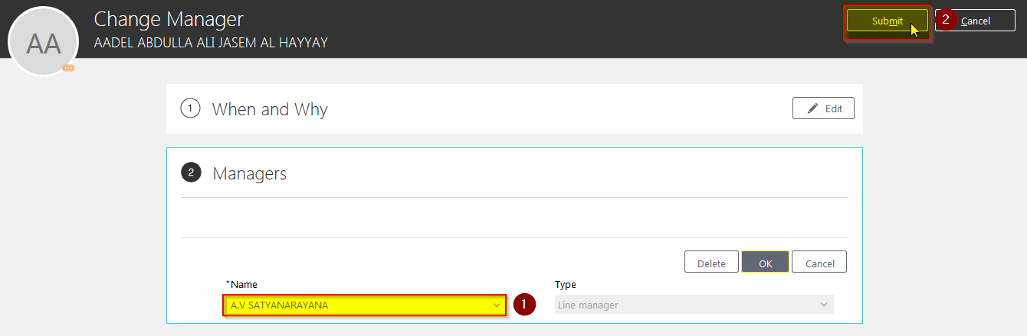

Change of Entry of Attendance Source

After assigning of Job Role “ETC CS HRSPOC Restricted” , following is the navigation for change or Entry of Location by HRPSOC
Navigation :
- From "Home Page"
- Click on "Home" Icon on Top Right
- Click on Options "My Client Groups"
- Click on link “Show More”
- Click on link “Change Assignment”
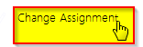

- A new page opens up, enter the staff number or name and select from the drop down as in the snapshot below
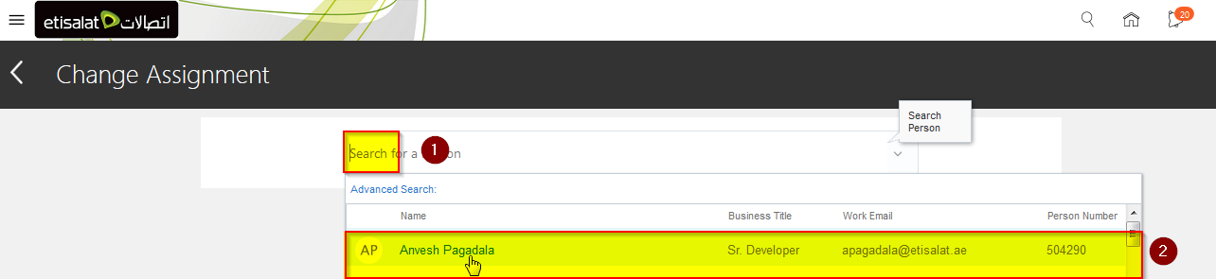
- A new page opens up, enter the “Change Assignment Start” Date and click on “Continue” Button
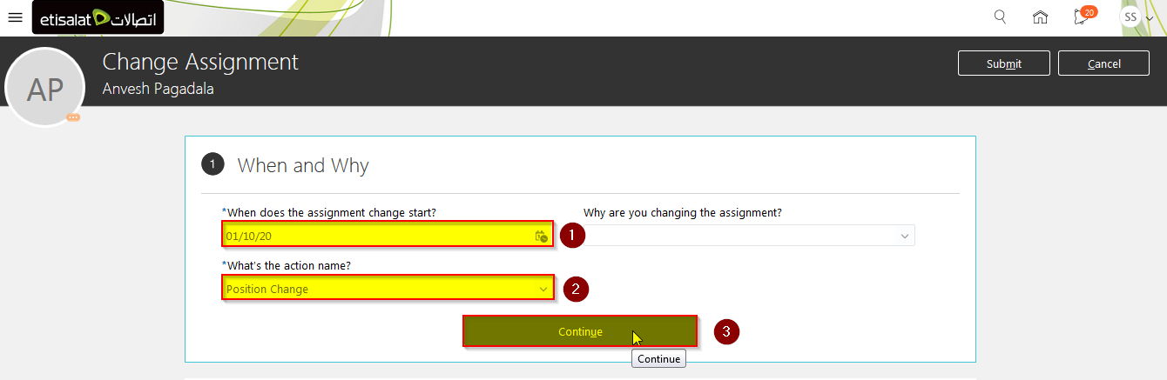
- A new page opens up, Enter or change the attendance source from the drop down as in the snapshot below and click on “Submit”, This Action Closes the Change Attendance Source Process
